|  |  |
| --- | --- |
| \\VFILERDPI\DPI-Home\OBRIENR2\My Documents\Downloads\PP logo.jpg |  |
| **COUNCIL ASSESSMENT REPORT**  HUNTER AND CENTRAL COAST REGIONAL PLANNING PANEL | |

|  |  |
| --- | --- |
| PANEL REFERENCE & DA NUMBER | PPSHCC-167  DA/2630/2022 |
| PROPOSAL | Health Services Facility |
| ADDRESS | Lot 1 & 2 DP 877977  31-33 Smith Street, CHARLESTOWN NSW 2290 |
| APPLICANT | |  | | --- | | Wilson Planning Pty Ltd | |
| OWNER | GPV Charlestown Pty Ltd |
| DA LODGEMENT DATE | 18 November 2022 |
| APPLICATION TYPE | Development Application |
| REGIONALLY SIGNIFICANT CRITERIA | Clause 5, Schedule 6 of *State Environmental Planning Policy (Planning Systems) 2021*: Private infrastructure and community facilities over $5 million. |
| CIV | $27,142,041.00 (excluding GST) |
| CLAUSE 4.6 REQUESTS | N/A |
| KEY SEPP/LEP | * *Environmental and Planning Assessment Act 1979* * *Environmental and Planning Assessment Regulation 2021* * *State Environmental Planning Policy (Biodiversity and Conservation) 2021* * *State Environmental Planning Policy (Industry and Employment) 2021* * *State Environmental Planning Policy (Resilience and Hazards) 2021* * *State Environmental Planning Policy (Transport and Infrastructure) 2021* * *State Environmental Planning Policy (Planning Systems) 2021* * *Lake Macquarie Local Environmental Plan 2014* * *Lake Macquarie Development Control Plan 2014* |
| TOTAL & UNIQUE SUBMISSIONS KEY ISSUES IN SUBMISSIONS | Council has received a total of 1 submission in relationship to parking availability |
| DOCUMENTS SUBMITTED FOR CONSIDERATION | Aboriginal Cultural Heritage Report;  Access report;  Acoustic report;  Arborists report;  Architectural Plans;  Civil Engineering Plan;  Contamination / remediation action plan;  Crime Risk Assessment;  Demolition Plan;  Geotechnical report;  Landscape Design Plan and Report;  Mine Subsidence Desktop Assessment;  Signage Plan;  Traffic and Parking Assessment;  Visual Impact Assessment;  Waste Management Plan; |
| SPECIAL INFRASTRUCTURE CONTRIBUTIONS (S7.24) | N/A |
| RECOMMENDATION | Approval, subject to conditions of consent |
| DRAFT CONDITIONS TO APPLICANT | YES |
| SCHEDULED MEETING DATE | 17 May 2023 |
| PREPARED BY | Scott Fatches, Development Planner  Reviewed by: Glen Mathews, Section Manager Development |
| DATE OF REPORT | 9 May 2023 |

**EXECUTIVE SUMMARY**

Consent is sought for a 4 storey (plus plant and lift overruns) health services facility, multi-level carpark (245 car spaces), and related infrastructure, signage, and landscaping.

Fit outs of Levels 1 and 4 are not included as part of this application. Accordingly, separate applications will be lodged for fit-out of these floors.

Levels 2 and 3 are to be fit-out for a medical centre to be used for the purpose of providing health services (including preventative care, diagnosis, medical or surgical treatment, counselling or alternative therapies) to out-patients only, where such services are principally provided by health care professionals.

The subject site is located at 31-33 Smith Street, Charlestown, legally known as (Lot 1 & 2 DP 877977 (‘the site’). The site is rectangular in shape with a frontage of 82m to The Pacific Highway to the west; 99 metres to Frederick Street to the south; and 82 metres to Smith Street to the east.

The site is currently vacant and has an area of approximately 8,096m2.The site contains various native and exotic trees along its three street frontages. There are existing vehicle access points to the site, from Frederick Street and Smith Street.

The site is located across two zones, B3 Commercial Core and B4 Mixed Use. The proposed Health Services Facility is permitted with consent pursuant to Section 2.60of the *State Environmental Planning Policy (Transport and Infrastructure) 2021* (‘Transport and Infrastructure SEPP’), being located within a prescribed zone.

It is noted the NSW Government Department of Planning and Environment employment zone reforms commenced in Lake Macquarie on 26 April 2023.

As part of the reforms the site is now zoned E2 Commercial Core and MU1 Mixed Use.

The Standard Instrument (Local Environmental Plans) Order 2006 includes a two-year transitional arrangement to continue land use permissibility where the translation to employment zones is altering the land use permissibility. Consequently, for the purpose of this report the reference to B3 and B4 will be maintained throughout.

The development site is located within a mine subsidence district and does not meet any deemed to satisfy provision. General terms of approval under Section 22 of the *Coal Mine Subsidence Compensation Act 2017* were obtained prior to lodgement with Council.

Advice was sought from Ausgrid for works in the vicinity of overhead powerlines and Transport for NSW (TfNSW) for traffic-generating development pursuant to the Transport and Infrastructure SEPP.

The development was referred to local NSW police in accordance with Council’s memorandum of understand. No response was received to date and it is assumed there is no objection to the development.

The application was placed on public exhibition from 28 November 2022 to 13 January 2023, with 1 submission being received. The submission raised issues relating to onsite and offsite car parking concerns. These issues are considered further in this report.

The application is referred to the Hunter and Central Coast Regional Planning Panel (the Panel) as the development is regionally significant development, pursuant to Section 2.19(1) and Clause 5(b) of Schedule 6 of *State Environmental Planning Policy (Planning Systems) 2021* as the proposal is development forhealth services facilities.

The proposal has a capital investment value (CIV) of $27,142,041 which triggers the application to become regionally significant development (i.e. health services facilities with a CIV of more than $5M).

A combined briefing and kick-off meeting was held for the application on 8 March 2023 where key issues were discussed, including streetscape/ building form presentation, tree removal, Subsidence Advisory requirements and site access.

Initial review of the relevant details relating to the building form of the multi-storey car park, identified insufficient design consideration on the presentation to the streetscape. The applicant submitted additional information which addressed this item and thus suitably demonstrated compliance with all relevant controls for streetscape presentation.

The issue of tree removal has been considered and the proposal is deemed acceptable for the purpose of this application. Retention of any tree would result in significant amendments to layout and design, compromising the function of the health services facility with heavy consideration needing to be given to the Tree Protection Zone (TPZ) dimensions for individual trees. Council is satisfied the proposal will provide replacement species consistent with the desired Streetscape Master Plan for Charlestown at this location.

Subsidence risk to the site has been consider within the submitted Mine Subsidence Desktop Assessment. Consent was issued by Subsidence Advisory NSW in accordance with the Notice of Determination letter dated 31 August 2022 (Ref: TBA22-02908).

Initial concerns were raised about the proposed development and Council’s intended future Charlestown to Whitebridge shared path route along Fredrick Street. The applicant submitted additional information which addressed this item and thus suitably demonstrated appropriate measures to reduce the conflicts associated with access from Frederick Street.

The application is accompanied by a suite of specialist report studies to identify potential impacts. Appropriate design outcomes and mitigation measures have been included to enable the development to co-exist with other surrounding uses without adverse impacts.

Following a detailed assessment of the proposal, pursuant to Section 4.16(1)(a) of the *EP&A Act*, DA/2630/2022 is recommended for approval subject to the draft conditions of consent attached to this report at Attachment A.

1. **THE SITE AND LOCALITY**
   1. **The Site**

The site is generally rectangular in shape with an area of 8096m2 known as 31-33 Smith St, Charlestown (Lot 1 & 2 DP 877977). The site is centrally located within Charlestown fronting The Pacific Highway to the west; Frederick Street to the south; and Smith Street to the east. The site shares a boundary to retail and business development to the north.

The site is currently vacant with various native and exotic trees along its three street frontages. Observations of the site noted fill stockpiles that are understood to originate from past remediation works. The site has a record of being possibly contaminated according to Council’s records. There are existing overhead powerline in Smith Street and Frederick Street.

The site has a gentle slope from north to south. There are several existing retaining walls around the perimeter of the site. Concrete and bitumen footpaths are located along all three road frontages.

The site has a history of underground coal mining within the Victoria Tunnel Seam and is subject to mine subsidence. No surface workings occurred on the site.

The site is not identified as being within a sensitive Aboriginal landscape area or any identified heritage items.

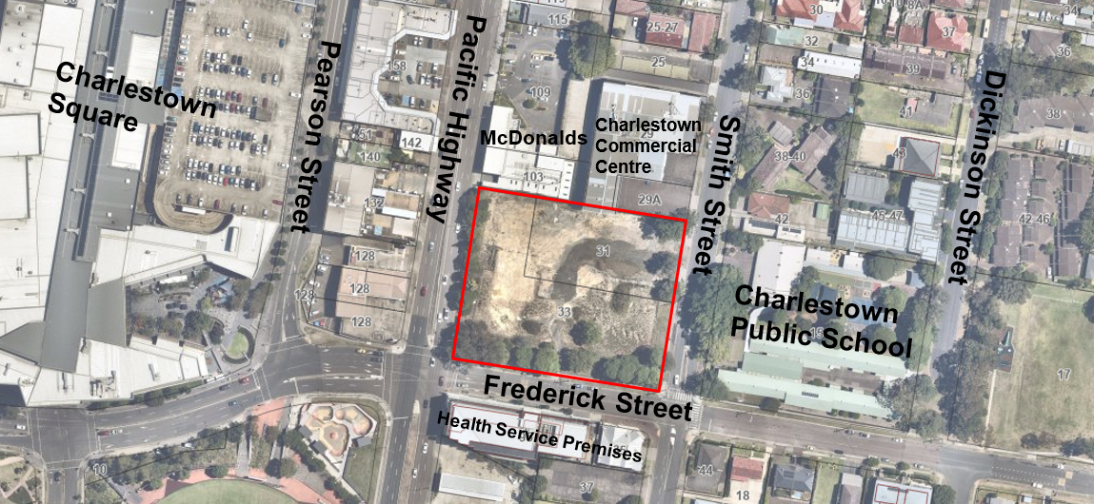

**Figure 1: Map of site and surrounding locality**

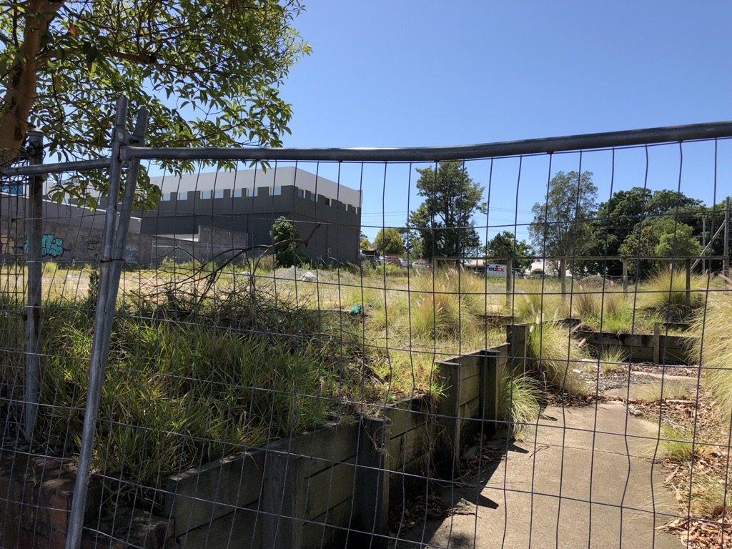

**Figure 2: Site Photo – Looking east from the Pacific Highway**

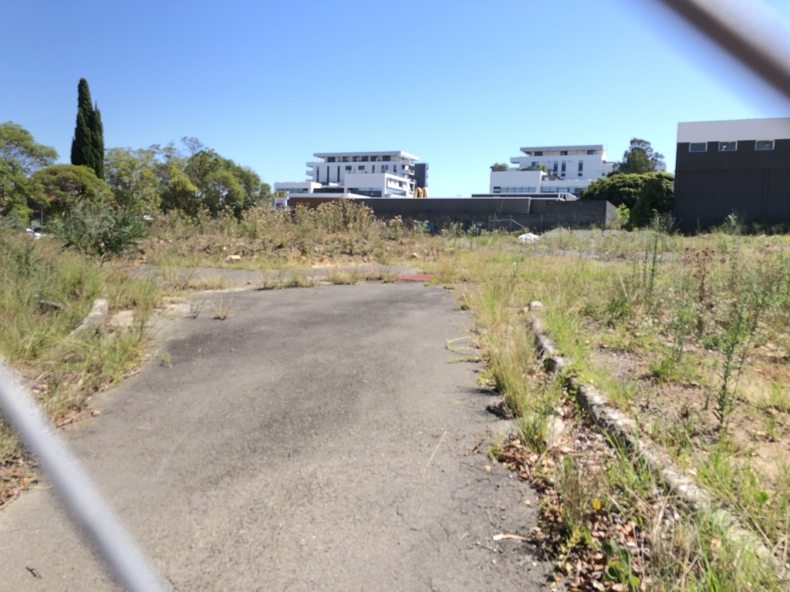

**Figure 3: Site Photo – Looking north from Frederick Street**

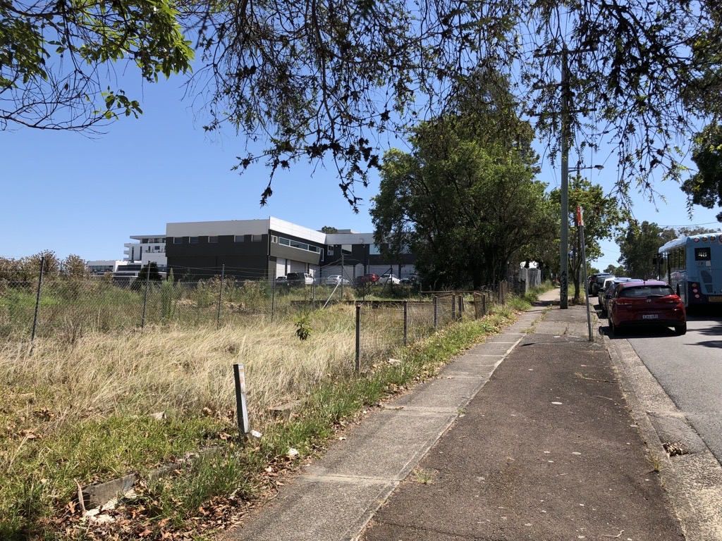

**Figure 4: Site Photo – Looking north-west from Smith Street**

* 1. **The Locality**

The site is located in the suburb of Charlestown, within the Lake Macquarie City Council (LMCC) local government area (LGA).

At the time of lodgement, the site was zoned B3 Commercial Core and B4 Mixed Use – pursuant to Clause 2.3 of the Lake Macquarie Local Environmental Plan 2014.

Immediately adjoining the site to the north is a single storey retail premises identified as McDonalds at 103 Pacific Highway and the Charlestown Commercial Centre, a two storey business premises at 29 Smith Street.

Charlestown Public School is located east of the site separated by Smith Street.

To the south are 2-3 storey health-related services such as a dermatology, hair studio and diagnostic imagery service, separated from the site by Frederick Street.

To the west the site adjoins the Pacific Highway, the major transport route to the north and south of the development site. The western side of the Pacific Highway is characterised by commercial development, including Charlestown Square.

The nearest bus stop terminal is on Pearson Street, which provides access to public transport from all compass points of the greater Newcastle area.

The site is not listed as a heritage item or located within a Heritage Conservation Area, however the site is located within 100m of the vicinity of the following listed heritage items:

* Heritage item 60 – Cottage (32 Smith Street, Charlestown); and
* Heritage item 61 – Brick Cottage (36 Smith Street, Charlestown).

1. **THE PROPOSAL AND BACKGROUND** 
   1. **The Proposal**

Consent is sought for a 4 storey (plus plant and lift overruns) health services facility, multi-level carpark (245 car spaces), and related infrastructure, signage, and landscaping.

Site excavation and demolition of existing features such as retaining walls, internal driveways and vegetation are proposed as site preparation works. All trees onsite plus two street trees are proposed to be removed.

Fit outs of Levels 1 and 4 are not included as part of this application. Accordingly, separate applications will be lodged for fit-out of these floors.

Levels 2 and 3 are to be fit-out for a medical centre to be used for the purpose of providing health services (including preventative care, diagnosis, medical or surgical treatment, counselling or alternative therapies) to out-patients only, where such services are principally provided by health care professionals.

The proposal includes one building, which will provide approximately 8,998m2 of floor space across four levels. The main building is orientated to The Pacific Highway and Frederick Street, with multi-level carpark orientated to Smith Street.

The health services facility comprises the following:

**Level 1 (Ground Floor) includes:**

* Five open tenancies subject to future applications for fit-out and use
* Potential uses include, GP Clinic, pathology, skin clinic, pharmacy and imaging
* a lift lobby with pedestrian access from the Pacific Highway and the Level 1 car park
* storage/ waste rooms and servicing rooms
* signage
* Visitor and staff car park with 81 car spaces, including 2 accessible spaces
* 4 space drop off and pick up bay, 3 loading/ delivery bays including a heavy vehicle bay and ambulance bay accessed from Frederick Street
* Landscaping improvements to streets, and internal areas

**Level 2** has been designed to accommodate:

* 14 medical and health consulting tenancies as part of the medical centre use
* amenities and lift lobby
* visitor and staff car park with 79 car spaces, including 2 accessible spaces
* Car park access off Smith Street via a combined entry / exit driveway

**Level 3** has been designed to accommodate:

* 13 medical and health consulting tenancies as part of the medical centre use
* staff parking area with 85 car spaces including 2 accessible spaces and turning bay
* amenities and lift lobby.

**Level 4** has been designed to accommodate:

* Provide 2,299m2 of gross floor area for future private hospital or day surgery subject to future application.

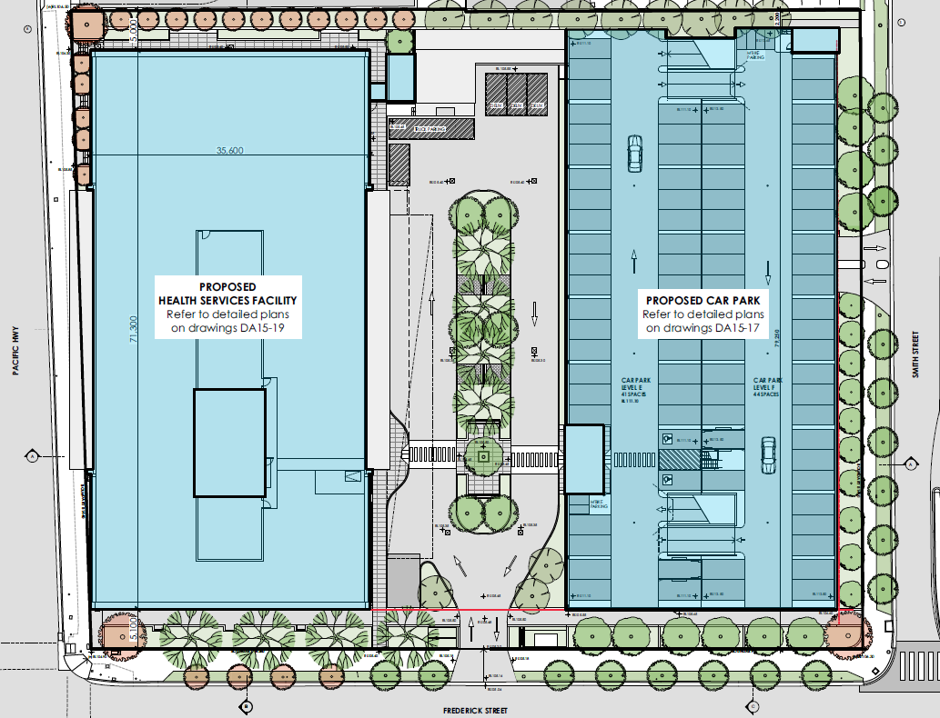

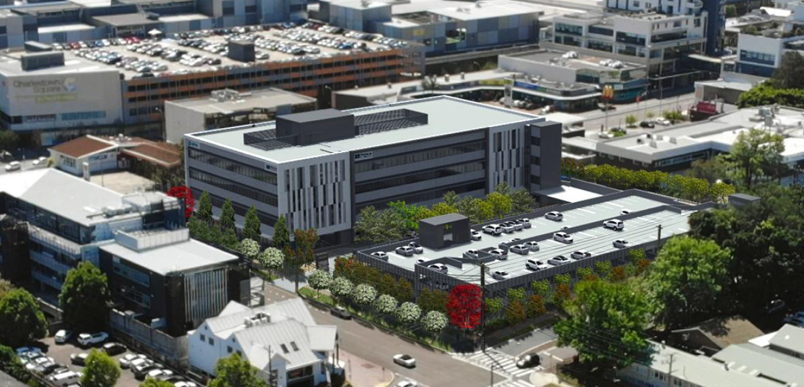**Figure 5: Proposed Development – General Layout/ Site Plan**

**Figure 6: Proposed Development – Concept 3D view**

**Table 1: Development Data**

|  |  |
| --- | --- |
| **Control** | **Proposal** |
| Site area | 8,096m2 |
| GFA | 8,998m2 |
| FSR (retail/residential) | N/A |
| Clause 4.6 Requests | No – The development does not request a variation to the development standards |
| Max Height | 22m |
| Landscaped area | 1540m2 / 19% of site |
| Car Parking spaces | 245 on-site car parks |
| Setbacks | 1.9m to northern boundary; 3m to eastern boundary; 5m to southern boundary; 0m to western boundary |

* 1. **Background**

A pre-lodgement meeting was held prior to the lodgement of the applicant on 2 November 2022 where various issues were discussed. A summary of the key items and how they have been addressed by the proposal is outlined below:

* Item 1 – DCP changes for Charlestown Area Plan

The applicant has provided the necessary documentation to satisfactorily address the relevant controls for the Charlestown Area Plan.

An assessment of the proposed development against the Charlestown Area Plan is provided in Section 5 of this report.

* Item 2 – Traffic, access and engineering comments

The applicant has satisfied the matters pertaining to traffic, access and civil design.

An assessment of the proposed development against these items are provided throughout this report.

* Item 3 – Landscaping Comments

The applicant has provided the necessary documentation to satisfactorily address the relevant controls for landscaping and matters under the Charlestown Streetscape Master Plan and Charlestown Area Plan.

An assessment of the proposed development against landscaping and the Charlestown Area Plan is provided in Section 5 of this report.

The development application was made to Council on **18 November 2022**. A chronology of the development application since lodgement is outlined below including the Panel’s involvement with the application is outlined in Table 2:

**Table 2: Chronology of the DA**

|  |  |
| --- | --- |
| **Date** | **Event** |
| 18 November 2022 | Application made to Council |
| 28 November 2022 – 13 January 2023 | Exhibition of the application |
| 1 December 2022 | DA referred to external agencies (TfNSW, Ausgrid & NSW Police) |
| 8 March 2023 | Panel briefing |
| 28 March 2023 | Request for Information from Council to applicant |
| 21 April 2023 | Amended plans lodged – primary changes included further improvements to the streetscape presentation of the proposal to reflect outcome of additional information requests. |
| 21 April 2023 | DA referred to external agencies (TfNSW) |
| 10 May 2023 | Response from TfNSW |
| 10 May 2023 | Assessment report and draft conditions lodged to Panel |

* 1. **Site History**

**Historic Use**

Historic records would indicate the site would be granted consent as a school between 1877-1879. The site operated as a school until it was decommissioned in the early 2000’s.

In September 2004 the school site was sold by the Minister for Education and Training to Lake Macquarie City Council for future redevelopment.

The site was sold to the current owners in 2017-18.

**DA/2114/2007**

Council approved a car parking facility on the site on 22 August 2008.

**DA/1912/2013**

Council approved demolition of the remains of the school building on the site on 6 February 2014.

**SSD-10351**

Council provided comments on 8 July 2019 to the Department of Planning & Environment on draft SEARs for a proposed Private Hospital and Medical Centre.

An application was lodged for the construction of a new private hospital and associated car parking. The status of this application was withdrawn.

**SSD-35241384**

Industry-specific SEARs were issued for the Charlestown Private Hospital and Medical Centre on 25 January 2022. The status of this application is still active.

**PL/86/2022**

A pre-lodgement meeting was held with Council on 2 November 2022 to discuss the subject health services facility.

**DA/2630/2022**

The development application was made to Council on 18 November 2022.

1. **STATUTORY CONSIDERATIONS**

When determining a development application, the consent authority must take into consideration the matters outlined in Section 4.15(1) of the *Environmental Planning and Assessment Act 1979* (‘EP&A Act’). These matters as are of relevance to the development application include the following:

1. *the provisions of any environmental planning instrument, proposed instrument, development control plan, planning agreement and the regulations*

*(i)  any environmental planning instrument, and*

*(ii)  any proposed instrument that is or has been the subject of public consultation under this Act and that has been notified to the consent authority (unless the Planning Secretary has notified the consent authority that the making of the proposed instrument has been deferred indefinitely or has not been approved), and*

*(iii)  any development control plan, and*

*(iiia)  any planning agreement that has been entered into under section 7.4, or any draft planning agreement that a developer has offered to enter into under section 7.4, and*

*(iv)  the regulations (to the extent that they prescribe matters for the purposes of this paragraph),*

*that apply to the land to which the development application relates,*

1. *the likely impacts of that development, including environmental impacts on both the natural and built environments, and social and economic impacts in the locality,*
2. *the suitability of the site for the development,*
3. *any submissions made in accordance with this Act or the regulations,*
4. *the public interest.*

These matters are further considered below.

Coal Mine Subsidence Compensation Act 2017

Section 22: Approvals for development within mine subsidence districts

The site is identified as being within a mine subsidence district. In accordance with Section 22, an application for approval to alter or erect improvements, or to subdivide land, within a mine subsidence district is to be made in a form approved by the Chief Executive.

The applicant obtained approval from Subsidence Advisory NSW prior to the lodgement of this application. Notice of Determination letter dated 31 August 2022 (Ref: TBA22-02908) was issued by Subsidence Advisory NSW providing general terms of approval (GTA). Should this application be approved, the notice of determination will incorporate the GTA’s issued by Subsidence Advisory NSW.

* 1. **Environmental Planning Instruments, proposed instrument, development control plan, planning agreement and the regulations**

The relevant environmental planning instruments, proposed instruments, development control plans, planning agreements and the matters for consideration under the Regulation are considered below.

1. **Section 4.15(1)(a)(i) - Provisions of Environmental Planning Instruments**

The following Environmental Planning Instruments are relevant to this application

* *Coal Mine Subsidence Compensation Act 2017*
* [*State Environmental Planning Policy (Planning Systems) 2021*](https://legislation.nsw.gov.au/view/html/inforce/current/epi-2021-0724)
* *State Environmental Planning Policy (Biodiversity and Conservation) 2021*
* [*State Environmental Planning Policy (Resilience and Hazards) 2021*](https://legislation.nsw.gov.au/view/html/inforce/current/epi-2021-0730)
* [*State Environmental Planning Policy (Transport and Infrastructure) 2021*](https://legislation.nsw.gov.au/view/html/inforce/current/epi-2021-0732)
* [*State Environmental Planning Policy (Industry and Employment) 2021*](https://legislation.nsw.gov.au/view/html/inforce/current/epi-2021-0723)
* *Lake Macquarie Local Environmental Plan 2014*
* *Lake Macquarie Development Control Plan 2014*

A summary of the key matters for consideration arising from these State Environmental Planning Policies are outlined in **Table 3** and considered in more detail below.

**Table 3: Summary of Applicable Environmental Planning Instruments**

|  |  |  |
| --- | --- | --- |
| **EPI** | **Matters for Consideration** | **Comply (Y/N)** |
| Coal Mine Subsidence Compensation Act 2017 | Section 22: Approvals for development within mine subsidence districts  The proposed development has been granted approval under section 22 of the *Coal Mine Subsidence Compensation Act 2017* – subject to the conditions of consent issued by Subsidence advisory NSW dated 31 August 2022 (Ref: TBA22-02908). | Y |
| SEPP (Biodiversity and Conservation) 2021 | Chapter 4 – Koala habitat protection 2021  The site is not a core koala habitat and it has limited habitat protected by this policy.  Council’s Ecologist has considered the proposal and is satisfied the proposal is acceptable. | Y |
| SEPP Planning Policy (Planning Systems) 2021 | Chapter 2: State and Regional Development  Section 2.19(1) declares the proposal regionally significant development pursuant to Clause 5 of Schedule 6 as it comprises pprivate infrastructure and community facilities over $5 million, but less than $30 million. | Y |
| SEPP (Resilience & Hazards) | Chapter 3: Hazardous and offensive development  The proposed development is not considered to be a potentially hazardous industry.  Chapter 4: Remediation of Land  Section 4.6 - Contamination and remediation has been considered in the Contamination Status Report prepared by Douglas Partners and the site is considered suitable for the proposed use with regards to contamination. | Y |
| SEPP (Transport and Infrastructure) 2021 | Chapter 2: Infrastructure   * Section 2.48(2) (Determination of development applications – other development) – electricity transmission – the proposal is satisfactory subject to conditions endorsed by the electricity supply authority (Ausgrid). * Section 2.60(1) (Development permitted with consent) – the development is identified as being within a prescribed zone for health services facilities (B3 & B4), and therefore is permitted with consent under this SEPP. * Section 2.119(2) – (Development with frontage to classified road) – The development has been considered to be satisfactory in regards to matters for consideration under this section. * Section 2.122(4) – (Traffic-generating development) – The development is identified as being traffic generating development with size or capacity for 200 or more car parking spaces. Written notice was given to TfNSW with advice being provided on different occasions. Consideration has been made with no adverse impacts as a result of this development and would be supported with conditions by TfNSW. | Y |
| SEPP (Industry and Employment) 2021 | Chapter 3: Advertisement and signage  No issues identified in accordance with assessment criteria under Schedule 5 of this SEPP. | Y |
| LMLEP2014 | * Clause 4.3 – The development is below the maximum building height limits of the site. * Clause 5.10 – There is a low-moderate potential for Aboriginal objects within the site. Recommended test excavations will be conditioned prior to any works. * Clause 7.2 – Earthworks have been considered to meet the provisions under Clause 7.2(3). * Clause 7.21 – The development has demonstrated that essential services are available to the site. | Y |
| LMDCP2014 | * Part 4: Development in Business Zones – The development generally complies with this section of the DCP. * Part 9.17 Signage – The development generally complies with this section of the DCP * Part 10.1: Charlestown Town Centre – The development generally complies with this section of the DCP | Y |

Consideration of the relevant SEPPs is outlined below;

State Environmental Planning Policy (Planning Systems) 2021

Chapter 2: State and Regional Development

The proposal is *regionally significant development* pursuant to Section 2.19(1). It satisfies the criteria in Clause 5 of Schedule 6 of the Planning Systems SEPP as development for private infrastructure and community facilities over $5 million as a health services facility, but less than $30 million.

Accordingly, the Hunter and Central Coast Regional Planning Panel is the consent authority for the application. The proposal is consistent with this Policy.

**State Environmental Planning Policy (Biodiversity and Conservation) 2021**

The site is not mapped on the Biodiversity Values Map and the proposed development will not exceed clearing thresholds set out under Section 7.2 and Section 7.3 of the NSW Biodiversity Conservation (BC) Regulation 2017.

The site is not a core koala habitat and it has limited habitat protected by this policy.

Council’s Development Planner – Flora and Fauna has considered the proposal and is satisfied the proposal is acceptable subject to recommended conditions of consent.

State Environmental Planning Policy (Resilience and Hazards) 2021

Chapter 3 - Hazardous and offensive development

The provisions of Chapter 3 of *State Environmental Planning Policy (Resilience and Hazards) 2021 (‘the* Resilience and Hazards SEPP’) is to ensure appropriate consideration to any application to carry out potentially hazardous or offensive development. The consent authority has sufficient information to assess whether the development is hazardous or offensive and to impose conditions to reduce or minimise any adverse impact.

*State Environmental Planning Policy No. 33 – Hazards and Offensive Development (SEPP 33)* was previously used as the basis for assessing whether a development fell under the policy’s definition of “potentially hazardous industry” or “potentially offensive industry”. This is now covered under Chapter 3 of the Resilience and Hazards SEPP.

No policy changes were made under the consolidation of SEPP 33 into the Resilience and Hazards SEPP. The screening process used to assess whether a development is “potentially hazardous” or “potentially offensive” remains applicable.

The screening process used to assess whether the Resilience and Hazards SEPP applies (in the context of potentially hazardous or potentially offensive industry) is documented in the Hazardous and Offensive Development Application Guidelines - *Applying SEPP 33* *hazardous and offensive development application guidelines* (*Applying SEPP 33*) published by the Department of Planning.

Information provided by the applicant would note the storage of the following materials:

* 8 x compressed air cylinders (Class 2.2);
* 3 x medical carbon dioxide cylinders (Class 2.2);
* 6 x medical nitrous oxide cylinders (Class 2.2 (5.1));
* 6 x medical air cylinders (Class 2.2); and
* 30 x medical oxygen cylinders (Class 2.2 (5.1))
* All gas cylinders are G size which have dimensions of 780mm high x 204mm diameter, and a weight of 54Kg

As such, a preliminary risk screening assessment was required to determine the permissibility and whether the development is hazardous or offensive and to impose any conditions to mitigate any adverse impact.

A preliminary risk screening assessment was provided (Opterr, April 2023) which concluded the proposed development would not be a potentially hazardous industry within the meaning of *State Environmental Planning Policy (Resilience and Hazards) 2021*.

The majority of dangerous goods (DGs) to be stored at the site are Class 2.2 non-flammable, non-toxic gases. A lesser amount of Class 5.1 oxidising substances will also be stored at the site. A summary of the classes and quantities of DGs to be stored at the site is provided in Table 4

**Table 4: Proposed Quantities of dangerous goods stored and handled**

|  |  |  |  |
| --- | --- | --- | --- |
| **Class or Division (Subsidiary hazard)** | **Description** | **Packing Group** | **Quantity (kg)** |
| 2.2 | Non-flammable, non-toxic gases | N/A | 918 |
| 2.2 (5.1) | Non-flammable, non-toxic gas with oxidising sub risk | N/A | 1,944 |

The proposed storage of the above goods will be located in the mid top northern section of the site, located within a dedicated ‘Gas Storage’ room measuring 40m2.

Table 5 indicates the *Applying SEPP 33* general screening threshold quantities for DG storage (Table 3 of *Applying SEPP 33*).

**Table 5: General screening threshold quantities (Source: Table 3 of Applying SEPP33). Bold values indicate those applicable to this assessment**

|  |  |  |
| --- | --- | --- |
| **Class or Division (Subsidiary hazard)** | **Description** | **Screening Threshold Quantity (kg)** |
| 2.2 | N/A | n/a |
| 5.1 | ammonium nitrate — high density fertiliser grade, kept on land zoned rural where rural industry is carried out, if the depot is at least 50 metres from the site boundary | 25,000 |
| ammonium nitrate — elsewhere | 5,000 |
| dry pool chlorine — if at a dedicated pool supply shop, in containers <30 kg | 2,500 |
| dry pool chlorine — if at a dedicated pool supply shop, in containers >30 kg | 1,000 |
| any other class 5.1 | 5,000 |

Threshold limits for the application of SEPP 33 are presented in Table 6 indicating the maximum quantity that can be stored at the site for each class. It is noted that Class 2.2 DGs are not subject to risk screening for SEPP 33. Substances with sub risks are assessed against the thresholds of both DG classes they belong to.

**Table 6: Quantities of dangerous goods stored and Applying SEPP 33 thresholds**

|  |  |  |  |  |  |  |
| --- | --- | --- | --- | --- | --- | --- |
| **Class or Division (Subsidiary hazard)** | **Description** | **Packing Group** | **Quantity (kg)** | **Apply SEPP33 Threshold (kg)** | **Does SEPP 33 Apply?** | **Minimum**  **Quantity Per Load**  **(kg)** |
| 2.2 | Non-flammable, non-toxic gases | N/A | 918 | N/A | No | N/A |
| 5.1  (5.1) | Non-flammable non-toxic gas with oxidising sub risk | N/A | 1,944 | 5,000 | No | 5,000 |

The quantities to be stored are less than SEPP 33 as shown in Table 6. A high turnover of stored product would be required to exceed the acceptable vehicular movements associated with the corresponding storage (>30 peak vehicle movement per week or >500 cumulative per year). Therefore, it is considered that the transport screening thresholds of *Applying SEPP 33* would not be exceeded by the proposed development.

A review of the quantities of DGs proposed to be stored as part of the proposed development has been conducted and compared to the threshold quantities outlined in *Applying SEPP 33*. The results of this assessment indicate that the quantities of DGs to be stored and transported do not exceed the threshold quantities specified by *Applying SEPP 33*.

As the facility does not meet the definition of a potentially hazardous and potentially offensive industry under the Resilience and Hazards SEPP a Preliminary Hazard Analysis for the proposed development is not required.

As a result of the above, it is also been satisfied that the development will not require concurrence under Section 43(b) of the Protection of the Environment Operations Act 1997 (POEO Act).

Conditions of consent shall be recommended to ensure the appropriate storage of proposed materials is well managed and to not exceed any screened quantities.

Chapter 4: Remediation of Land

The provisions of Chapter 4 of *State Environmental Planning Policy (Resilience and Hazards) 2021 (‘the* Resilience and Hazards SEPP’) have been considered in the assessment of the development application. Section 4.6 of Resilience and Hazards SEPP requires consent authorities to consider whether the land is contaminated. If the land is contaminated, the consent authority must be satisfied the land is suitable in its contaminated state (or will be suitable, after remediation) for the purpose for which the development is proposed to be carried out.

Assessment of potential contamination has been submitted with the application, including a Contamination Status Report prepared by Douglas Partners (DP). The assessment identified a number of contamination and remediation reports that occurred over the site.

The site history review undertaken as part of the Preliminary Geotechnical and Site Investigation (Contamination) (DP, 2014a) indicated that the site had been used as a school prior to 1954 up until about 2006. From 2006 to 2009, the majority of former site buildings were subject to demolition with the remaining buildings in the southern part of the site removed mid-2014. A carpark was constructed from late 2009 to 2010.

A ‘Detailed Site Investigation’ (DSI) was undertaken by DP in November 2014 (DP, 2014b) for the purposes of assessing geotechnical conditions and contamination status at the site for a preliminary multi-storey residential development. An ‘Additional Investigation for Contamination’ was also undertaken in August 2016 (DP, 2016a) to further assess the possible extent of contaminated slag/ash fill which exceeded the adopted land use assessment criteria for the previously proposed residential development.

The majority of test locations focused on the northern part of the site (area of contamination risk) based on the site history. The results of the assessment generally indicated the absence of gross contamination to soils at the locations and depths tested.

A remediation action plan (RAP) (DP, 2016b) was developed based on available standards and guidelines prepared by the relevant authorities, and the results of geotechnical and contamination investigations conducted by DP for the proposed development as described above.

In 2017 remediation of the impacted fill within the northern portion of the site was undertaken by Lake Macquarie City Council (LMCC) who at the time were the site owners. Remediation involved the progressive stripping and off-site disposal of the impacted materials and validation inspections, sampling and testing by DP.

Based on the results of the validation inspections and testing as presented in the validation of remediation report (DP, 2018), the identified areas of contamination were appropriately remediated in accordance with the RAP (DP, 2016b).

Soils found to contain contaminant concentrations exceeding the remediation action criteria (i.e. HIL B) were removed from the site as part of the remediation works. As a result, DP determined the site was suitable for development.

A recent DP investigation undertaken in April 2022 involved the waste classification of several stockpiles comprising upper fill ‘clean’ materials stockpiled during previous remediation works in 2017. The waste classification confirmed materials were classified as Recovered Aggregate with reference to NSW EPA.

A site walkover was undertaken by DP on 9 June 2022. The following key site features pertinent to this assessment were observed:

* The site appeared vacant with similar site conditions observed during the remediation and validation works undertaken in 2018;
* Remnants of fill stockpiles originating from the remediation works in 2018 were observed in the north western portion of the site. The previous reports classified the stockpiles as fill within the concentrations of the then proposed development (HIL B) which can remain onsite from a contamination perspective;
* A stockpile of quarried gravel and cobbles were piled and spread in the central south eastern portion of the site for use as an access track. The gravel and cobbles comprised natural ballast material and showed no signs of contamination;
* Stockpiles of stripped surface fill were observed in the south western and south central portions of the site
* The stockpiled fill comprised intermixed building materials (brick, concrete, ceramics and metal)
* Portions of the northern and south western sections of the site comprised natural clay and sandstone at the surface

Based on the above, the previous contamination investigations, remediation and validation conducted by DP along with the updated aerial photo review and site inspection, the site is considered suitable for the proposed development with regards to contamination.

**State Environmental Planning Policy (Transport and Infrastructure) 2021**

Chapter 2 Infrastructure – Division 5 Subdivision 2 Development likely to affect an electricity transmission or distribution network

The site has overhead powerlines along both its Frederick Street and Smith Street frontages and works are proposed within 5m of these. Referral to Ausgrid formed part of the assessment process for comments of these arrangements. Ausgrid provided their comments on 4 December 2022 as follows:

*Ausgrid requires that due consideration be given to the compatibility of proposed development with existing Ausgrid’s infrastructure, particularly in relation to risks of electrocution, fire risks, Electric & Magnetic Fields (EMFs), noise, visual amenity and other matters that may impact on Ausgrid or the development.*

*It was identified that the “as constructed” minimum clearances will not be encroached by the development.*

*The existing overhead mains may require relocating should the minimum safety clearances be compromised during construction; this relocation work is generally at the developers cost.*

Subject to approval, a condition of consent will be imposed requiring compliance with Ausgrid requirements.

Chapter 2 Infrastructure – Division 10 Health Services Facilities

Pursuant to clause 2.60(1), health services facilities are permissible in the B3 and B4 zoned. Health Services facilities are defined as:

*health services facility means a building or place used to provide medical or other services relating to the maintenance or improvement of the health, or the restoration to health, of persons or the prevention of disease in or treatment of injury to persons, and includes any of the following—*

*(a) a medical centre,*

*(b) community health service facilities,*

*(c) health consulting rooms,*

*(d) patient transport facilities, including helipads and ambulance facilities,*

*(e) hospital.*

Elements of the development and future uses can meet the above definitions of a health services facility.

The application meets the definition of a health services facility. Therefore, the proposal is permissible under the SEPP.

Chapter 2 Infrastructure – Division 17, Roads and Traffic

Section 2.119 – Development with frontage to classified road

The development adjoins the Pacific Highway which requires consideration under Section 2.119 of the SEPP.

No access is proposed off the classified road that adjoins the property, with access proposed from Frederick and Smith Street.

Regarding the safety, efficiency and ongoing operation of the classified road, a traffic & parking assessment report (Intersect Traffic April 2023) was prepared, modelling the impact of this development on intersections adjoining the Pacific Highway.

Car parking facility between 100 and 300 car spaces fronting a local road, require a category 3 access (Table 3.1 of AS 2890.1-2004).

The proposed access arrangements for the development can comply with the requirements of AS2890.1-2004.

Pedestrian and vehicular sight lines from the accesses will be achieved with the provision of appropriately designed landscaping being either managed or lower than 1.2 metres high. Vehicular sight distances at the accesses have been observed to be a minimum 70 metres on Frederick Street and Smith Street which is considered compliant with AS2890.1-2004 for a 50 km/h speed frontage.

Overall, it is concluded that the proposed access arrangements will not adversely impact upon the classified road.

The proposal will have little effect on air quality. Emissions resulting from construction will be temporary and negligible. There is no predicted increase in the occurrence of smoke or dust as a result of operations of the health services facility.

Overall, it is concluded that the proposed development will not adversely impact upon the classified road from contributing dust or smoke. Appropriate conditions of consent can be put in place for the control of emissions and dust during construction.

Traffic modelling was used to identify the nature, volume and frequency of vehicles using the classified road to gain access to the site.

Manual intersection counts at the Pacific Highway/ Frederick Street and Frederick Street/ Smith Street occurred over a 24-hour periods. Whilst primarily undertaken to allow the intersections to be modelled for future traffic conditions these counts also provide a guide to the current mid-block traffic volumes on the local road network. The peak traffic periods were found to be 7.45 am to 9 am and 3 pm to 5.30 pm.

The report identifies the local road network is currently operating within its technical capacity for two-way mid-block traffic volumes.

The RTA’s Guide to Traffic Generating Developments, rate for Extended Hours Medical Centres was considered the most relevant available data to determine the nature, volume or frequency of vehicles from the classified road to the proposed site.

A summary of the proposed traffic generation to the development was calculated as follows:

* Pacific Highway north of Frederick Street – 134 vtph in the AM peak and 126 vtph in the PM peak.
* Pacific Highway south of Frederick Street – 27 vtph in the AM peak and 25 vtph in the PM peak.

When this additional traffic is added to the existing traffic volumes on the road network and including a background traffic growth rate of 1.5 % per annum the following two-way mid-block capacity assessment as shown in the table below is:

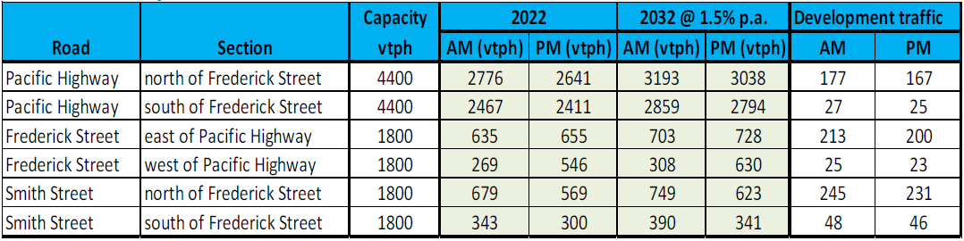

This assessment has shown that even with the additional development traffic from the proposed private hospital and background traffic growth the local and state road network will remain below the two-way mid-block capacity of the road network through to and beyond 2032.

It is therefore concluded that subject to satisfactory intersection performance the development will not adversely impact on the classified road network.

The application has demonstrated that the development will not be sensitive to traffic noises by including appropriate design measures, to ameliorate potential traffic noise or vehicle emissions arising from the adjacent classified road.

An acoustic report has been prepared (Reverb Acoustics, September 2022), citing the relevant guidelines and technical references (i.e Department of Planning *Development near Rail Corridors and Busy Roads* (2008) and RTA *Guide to Traffic Generating Developments* (2002)). The acoustic report provides a review of road traffic noise and recommended glazing requirements to ensure impacts to the proposed building are minimised.

Reporting indicates the site would be impacted by road traffic noise and additional sound insulation design measures are required to meet the above guidelines.

The report has demonstrated that noise control is required to meet the noise assessment criteria set for the proposed development and provides construction recommendations in Section 7 of the acoustic report.

The report has demonstrated that the site is suitable for the intended purpose, providing the recommendations of the report are implemented at the design stage.

The recommendations and standard conditions for acoustic comfort will be recommended with any consent.

The consent authority can be satisfied the matters under Section 2.119 have been consider and appropriately addressed for the proposed development.

Section 2.120 – Impact of road noise or vibration on non-road development

The site is not identified to be on land in or adjacent road corridor that has an annual average daily traffic volume of more than 20,000 vehicles (based on the traffic volume data published on the website of TfNSW).

Section 2.122 – Traffic Generating Development

The development is traffic generating development under clause 2.122 and Schedule 3 of the SEPP, as the application proposes more than 200 onsite car parking spaces.

The application has been referred to Transport for NSW (TfNSW) on several occasions to address a request for further information on 21 December 2022 and 28 February 2023.

Initial concerns related to the proposed stormwater system and modelling for traffic assessment.

TfNSW raised additional matters for consideration which have been appropriately addressed throughout this report and or addressed through recommended conditions of consent.

TfNSW has reviewed the additional information and now raises no objection to the proposed development, provided the recommended conditions are included in the consent.

State Environmental Planning Policy (Industry and Employment) 2021

Chapter 3 – Advertisement and signage

The proposal involves the erection of the following signage:

* indicative building identification signage on western and eastern elevation of the building and eastern elevation on the multi-storey car park
* Indicative business initiation signage
* Installation of a freestanding pylon sign – 5.5m in height located at the southern access driveway on Frederick Street
* Installation of a business identification sign – 4.3m in height located north-eastern corner atop car park stairs
* Multiple wayfinding directional signage pylons located at the proposed entries and internal within the site

The proposed signage is considered consistent with the definition of a ‘***Business Identification Sign***’ and ‘***building identification sign’*** as provided under the SEPP, as its primary purpose is for the identification of the building and future business operations on the subject lot. Consequently, Chapter 3 section 3.6 of the SEPP provides that the proposal must be consistent with:

* The objectives of the SEPP; and
* The assessment criteria provided in Schedule 5 of the SEPP.

Concurrence with TfNSW was not required as the signage was not for advertisement.

An assessment of the proposal with regard to these matters is provided below.

Six business identification signs are proposed on all elevations, located atop corners of the health services facility building (1,550mm x 5,100mm). The signage will be illuminated.

One separate business identification sign is proposed located in the north eastern corner of the site adjacent Smith Street atop the carpark stairwell (4,300mm x 2,800mm). This signage will be illuminated and will display individual businesses.

Two building identification signs are proposed atop building entries on the western façade (externally to the Pacific Highway) and eastern façade entry (internally within the site) (1,600mm x 5,100mm). The signage will be illuminated.

One free-standing pylon business/ building identification sign is proposed at the boundary on Frederick Street, located adjacent the access to the site. The pylon signage will be 5,500mm x 2,400mm and will be illuminated. Wayfinding details will be provided on this sign to give directions on drop-off/ pick up areas and direction for onsite parking on Smith Street.

An assessment against Schedule 5 of SEPP has been provided in table 7:

**Table 7: Schedule 5 Assessment Criteria**

|  |  |  |
| --- | --- | --- |
| **State Environmental Planning Policy (Industry and Employment) 2021**  **Chapter 3 Advertising and Signage – Schedule 5 Assessment Criteria** | | |
| Matter for Consideration | Comment | Comply |
| 1. **Character of the area**  Is the proposal compatible with the existing or desired future character of the area or locality in which it is proposed to be located? | The signage is for identification of the proposed business and building and is compatible with the area in which it is proposed.  The building signage is consistent with other signage along the Pacific highway, Frederick Street and Smith Street. Generally, these sections of road is proliferated by signage by multiple businesses and therefore the proposal is consistent with the existing and desired future character of the area. | Y |
| Is the proposal consistent with a particular theme for outdoor advertising in the area or locality? | The signage is consistent with the surrounding commercial zoning | Y |
| **2. Special areas**  Does the proposal detract from the amenity or visual quality of any environmentally sensitive areas, heritage areas, natural or other conservation areas, open space areas, waterways, rural landscapes or residential areas? | The subject site is located within the B3 and B4 zoning. Given the scale of the signage and the character of the surrounding area it is considered that impacts to the surrounding environment will be negligible. | Y |
| **3. Views and vistas**  Does the proposal obscure or compromise important views? | The proposed signage is attached walls and located at ground level at certain areas and is not considered to obscure important views | Y |
| Does the proposal dominate the skyline and reduce the quality of vistas? | The proposed signage will not dominate the skyline or protrude higher than the proposed roofline of the development | Y |
| Does the proposal respect the viewing rights of other advertisers? | Yes | Y |
| **4. Streetscape, setting or landscape**  Is the scale, proportion and form of the proposal appropriate for the streetscape, setting or landscape? | The scale, proportion and form of the signage is appropriate for its location within the streetscape of each road frontage, the commercial setting and landscape. | Y |
| Does the proposal contribute to the visual interest of the streetscape, setting or landscape? | The signage retains the visual interest of the within the streetscape and commercial setting. | Y |
| Does the proposal reduce clutter by rationalising and simplifying existing advertising? | The proposal increases the amount of signage in the area. However, the amount of signage is not considered excessive and is considered acceptable that the messaging is simplified for the context that it is used for identification | Y |
| Does the proposal screen unsightliness? | Yes, the pylon signage will screen an electrical kiosk at ground level proposed from the western elevation from Frederick Street | Y |
| Does the proposal protrude above buildings, structures or tree canopies in the area or locality? | The proposed signage does not protrude above the building to which it is attached. | Y |
| Does the proposal require ongoing vegetation management? | Proposed vegetation in proximity to the proposed pylon sign located at the proposed site access on Frederick Street may require vegetation management. Notwithstanding, this is considered easily manageable | Y |
| **5. Site and building**  Is the proposal compatible with the scale, proportion and other characteristics of the site or building, or both, on which the proposed sign age is to be located? | The proposed signage is consistent with the scale and proportion of the existing building facades. | Y |
| Does the proposal respect important features of the site or building, or both? | There are no significant features of the site impacted by the signage. | Y |
| Does the proposal show innovation and imagination in its relationship to the site or building, or both? | The proposed signage is considered appropriate within the context of a health services facility. The signage proposed is for building/ business identification and wayfinding signage that directs users of the site to their destination. | Y |
| **6. Associated devices and logos with advertisements and advertising structures**  Have any safety devices, platforms, lighting devices or logos been designed as an integral part of the signage or structure on which it is to be displayed? | The signage is for the purpose of business identification. There are no safety devices, platforms or lighting devices contain as an integral part of the signage or structure. | N/A |
| **7. Illumination**  Would illumination result in unacceptable glare? | The sign will be internally illuminated. The proposed signage is not anticipated to result in any unacceptable glare | Y |
| Would illumination affect safety for pedestrians, vehicles or aircraft? | The signage is not proposed to move or flash in any way. It is not considered to detract from the safety of observers | Y |
| Would illumination detract from the amenity of any residence or other form of accommodation? | No. Conditions of consent will be recommended enforcing the level of luminance during periods of the day/night to mitigate | Y |
| Can the intensity of the illumination be adjusted, if necessary? | Yes, the signage will be able to be adjusted if necessary. Conditions of consent will be recommended enforcing the level of illuminance during periods of the day/night | Y |
| Is the illumination subject to a curfew? | No curfew has been proposed and or is considered necessary for the illuminated signs within the context of the development site. Conditions of consent will be recommended enforcing the level of luminance during periods of the day/night to mitigate | N/A |
| **8. Safety**  Would the proposal reduce the safety for any public road? | No, the proposed signage will be fixed to the proposed building and or pylon signage located inside the site. | Y |
| Would the proposal reduce the safety for pedestrians or bicyclists? | No, the proposed signage will be fixed to the proposed building and or pylon signage located inside the site. | Y |
| Would the proposal reduce the safety for pedestrians, particularly children, by obscuring sightlines from public areas? | It is not anticipated that the signage will obscure sightlines from public areas, ensuring that it does not reduce the safety of pedestrians, particularly children. | Y |

Accordingly, the proposed signage is considered to be of a scale and design suitable for the locality. The proposal is therefore deemed to be consistent with the provisions of the SEPP and its underlying objectives.

**Lake Macquarie Local Environmental Plan 2014**

The relevant local environmental plan applying to the site is the *Lake Macquarie Local Environmental Plan 2014* (‘the LEP’). The aims of the LEP include to promote the efficient and equitable provision of public services, infrastructure and amenities. The proposal is consistent with these aims, providing essential health services to meet the needs of the local and wider community.

The site was located within the B3 – Commercial Core and B4 – Mixed Usepursuant to Clause 2.2 of the LEP.

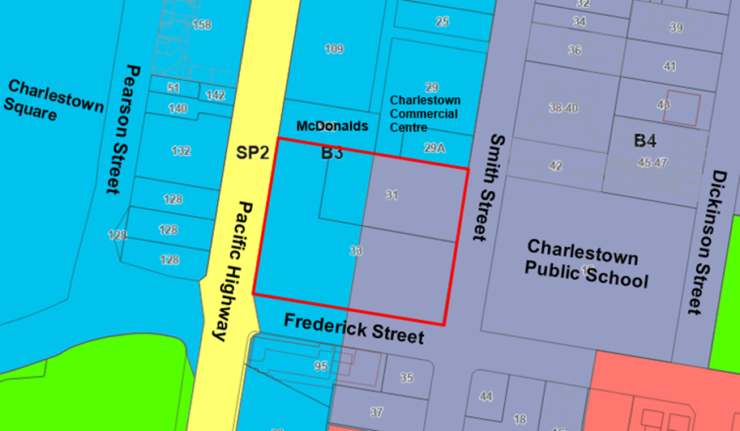

**Figure 7: Land Zone Map**

According to the definitions in Clause 1.4 (contained in the Dictionary), the proposal satisfies the definition of a health services facility.

Permissibility for the development is attained through clause 2.60(1) of *SEPP (Transport & Infrastructure) 2021* as outlined in earlier sections of the report.

The zone objectives are:

**B3 Commercial Core**

* To provide a wide range of retail, business, office, entertainment, community and other suitable land uses that serve the needs of the local and wider community.
* To encourage appropriate employment opportunities in accessible locations.
* To maximise public transport patronage and encourage walking and cycling.
* To create urban centres and public spaces that are safe, accessible, welcoming and are a central focus for the community.
* To provide for housing as part of mixed-use developments.
* To strengthen the roles of Charlestown, Glendale and Morisset as regional centres.

**B4 Mixed Use**

* To provide a mixture of compatible land uses.
* To integrate suitable business, office, residential, retail and other development in accessible locations so as to maximise public transport patronage and encourage walking and cycling.
* To enable development that complements and enhances the core retail function and trading performance of Zone B2 Local Centre and Zone B3 Commercial Core.

The proposal is considered to be consistent with these zone objectives for the following reasons:

* The development will provide essential health services that can serve the needs of the local and wider community and is compatible with other surrounding land uses.
* Maximises opportunities for public transport usage, co-location of health-related services and facilities within Charlestown and pedestrian linkages to other commercial and retail development and supports and complements retail and commercial development in the adjoining commercial zones.
* Provides significant short and long employment opportunities in an accessible location (point and assists in elevating Charlestown to be the regional centre it is envisaged to be.

The LEP also contains controls relating to development standards, miscellaneous provisions and local provisions. The controls relevant to the proposal are considered in Table 8 below.

**Table 8: Consideration of the LEP Controls**

|  |  |  |  |
| --- | --- | --- | --- |
| ***Lake Macquarie Local Environmental Plan 2014*** | | | |
| Control | Requirement | Proposal | Comply |
| Height of buildings  (Cl 4.3(2)) | 36.5 metres (B3)  23 metres (B4) | The maximum building height of the development will be 22 metres. | Yes |
| Heritage conservation  (Cl 5.10) | Disturbing or excavating an Aboriginal place of heritage significance | There is a low-moderate potential for Aboriginal objects within the site. Due to the limited AHIMS clarity of any items on site, test excavations are proposed to ensure no presence of items are found. This can be conditioned prior to any works. | Yes |
| Earthworks  (Cl 7.2) | Will not have a detrimental impact on environmental functions and processes, neighbouring uses, cultural or heritage items or features of the surrounding land | It is considered the extent of earthworks are consistent with the matters for consideration under this clause.  No objections have been raised. | Yes |
| Essential Services  (Cl 7.21) | Supply of water, electricity, management of sewage, stormwater drainage, vehicle access | All essential services are available to the development in accordance with the proposed infrastructure plan. | Yes |

1. **Section 4.15 (1)(a)(ii) - Provisions of any Proposed Instruments**

The NSW Government Department of Planning and Environment employment zone reforms commenced in Lake Macquarie on 26 April 2023.

As part of the reforms the site is now zoned E2 Commercial Core and MU1 Mixed Use accordingly.

The Standard Instrument (Local Environmental Plans) Order 2006 includes a two-year transitional arrangement to continue land use permissibility where the translation to employment zones is altering the land use permissibility.

These new reforms permit hospitals within the E2 zone which was prohibited by the previous B3 zone.

Irrespective of this the proposal was received prior to commencement of the provision and is afforded permissibility under the *State Environmental Planning Policy (Transport and Infrastructure) 2021*.

1. **Section 4.15(1)(a)(iii) - Provisions of any Development Control Plan**

The following Development Control Plan is relevant to this application:

* Lake Macquarie Development Control Plan 2014 (‘the DCP’)

Part 4 Development in Business Zones, Part 9.17 Signage also applies as the development includes signage and Part 10.1 Charlestown Town Centre area plan.

The proposal is generally consistent with the controls listed under Part 4, 9.17 and 10.1 of the DCP.

A summary of the key matters for consideration arising from the DCP are outlined in Table 9.

**Table 9: Summary of DCP controls**

|  |  |  |
| --- | --- | --- |
| **Part 4 – Development in Business Zones** | | |
| Control | Consideration | Comply |

|  |  |  |
| --- | --- | --- |
| Geotechnical  (S2.3) | A suitable geotechnical report prepared by Douglas Partners (November 2022) has been submitted and is considered satisfactory. A condition will be placed on the consent requiring compliance with the recommendations of the report. | Y |
| Cut & Fill  (S 2.4) | A cut and fill plan has been provided. The plan identifies that the majority of the site will be cut.  The development has minimised land shaping where feasible, and together with the proposed onsite stormwater management plan, will not exacerbate groundwater flows and or impact on adjoining properties.  Council’s Development Engineer is generally supportive of the proposed cut and fill subject to recommended conditions of consent. | Y |
| Stormwater Management  (S 2.8) | Council’s Development Engineer notes a suitable Stormwater Management Plan incorporating detention, water harvesting, water quality facilities and site discharge index requirements in accordance with the Lake Macquarie DCP 2014 has been provided. The plan is considered adequate for DA purposes. | Y |
| Preservation of Trees  (S 2.14) | Council does not object to the proposed tree removal, subject to the implementation of the proposed landscape plan. Refer to section 5 of this report for details. | Y |
| Aboriginal Heritage  (S2.16) | While the site is not identified as a sensitive Aboriginal landscape area or identified by AHIMS as containing any recorded sites or declared places within 200m the applicant has provided an Aboriginal Cultural Heritage Assessment Report. The assessment was prepared by Heritage Now dated 10/11/2022 (ref: HN000440-A).  The report was undertaken in accordance with Heritage NSW requirements, including consultation, as per ‘Aboriginal Cultural Heritage Consultation Requirements for Proponents (DECCW 2010)’.  The report identified a low-moderate potential for Aboriginal objects within the site.  It has been recommended to undertake test excavations prior to any works.  Council’s Development Planner – Heritage has reviewed the submitted documentation and raises no objections to the proposal on heritage grounds. The recommendations in the report should be included as conditions of consent. | Y |
| Streetscape Improvements  (S 3.4) | The proposal has been developed generally in accordance with the Charlestown Streetscape Masterplan. Council’s Development Planner – Landscape has reviewed proposed streetscape upgrades and raised no objections subject to recommended conditions. | Y |
| Non-Discriminatory Access  (S 3.5) | An Access Report prepared by Lindsay Perry Access (18 November 2022) demonstrates the fundamental aims of accessibility legislation is achievable for the development. Other details such as floor finishes, tactile surfaces will be confirmed through the Construction Certificate and recommended conditions of consent. | Y |
| Traffic and Vehicle Access  (S 5.1) | Vehicle access is generally consistent with the DCP and is supported by Council’s Development and Traffic Engineers.  Discussions have been held with Keolis Downer and has been recommended that a new bus stop be provided to service the proposal on the western side of Smith Street, immediately north of Frederick Street. This will allow existing bus route 48 to service the site. Keolis Downer have indicated their support for this location. A copy of their correspondence is attached to the amended Traffic and Parking Assessment prepared by Intersect Traffic.  The provisions for the bus stop will form part of any consent issued under this application.  Refer to section 5 of this report for details. | Y |
| Car Parking Rates  (S 5.5) | The proposed car parking meet the required rates of the DCP.  Provisions for electrical vehicle charging stations have been made.  Refer to section 5 of this report for details. | Y |
| Façade Articulation  (S 6.4) | Façade articulation are generally consistent with the DCP.  Refer to section 5 of this report for details. | Y |
| Building Exteriors  (S 6.5) | Building exteriors are generally consistent with the DCP.  Refer to section 5 of this report for details. | Y |
| Side and Rear Setbacks  (S 6.7) | The proposed development meets the desired setbacks of being partially built to the boundary on the Pacific Highway, approximately 5.6m for the building and 2.2m for the car park when above-ground to the northern boundary, 5m off Frederick Street, and 3m from Smith Street, in accordance with the Charlestown Town Centre Area Plan. | Y |
| Minimum Landscaped Area  (S 6.8) | The development provides approximately 19% of landscaped area, the development falls short of the desired 20% requirement.  Notwithstanding, the variation is considered minor and the overall the development meets the objectives of the DCP by providing appropriate landscaping within the context of the development and site area. | N |
| Safety and Security  (S 6.25) | The design and crime prevention strategy have been reviewed and supported by Council's Community Planner – Youth and Safer Communities, with additional conditions recommended to ensure appropriate lighting, secure locking systems and CCTV installation and coverage.  Refer to section 5 of this report for details. | Y |
| Landscape Design  (S 7.1) | Appropriate landscape documentation has been prepared and submitted in accordance with the DCP. | Y |
| Street Trees and Streetscape Improvements  (S 7.2) | Proposed street trees have been designed generally in accordance with the Charlestown Streetscape Master Plan.  The proposed street trees are an acceptable replacement to the trees that are proposed to be removed. | Y |
| Operational Waste Management  (S 8.2) | All refuse will be stored in the Waste Storage Room on Level 1 of the building. The total area is 25.8m2, and considered sufficient for the number of bins required for the frequency of collection proposed, and use of the building.  Each bin requires a footprint of 1.7m2. 3 x 1100L bulk bins will be accommodated, therefore 5.1m2 of space required at a minimum. There is ample room in the waste storage room to accommodate the predicted waste generation. | Y |
| Noise & Vibration  (s 8.7) | An acoustic report has been prepared by Reverb Acoustics Pty Ltd and accompanies the application, which is discussed in further detail in Section 5.  The report makes various recommendations to ensure that potential acoustic impacts resulting from the centre will be adequately ameliorated. If these recommendations are adopted, the report concludes that the proposed centre should result in minimal impact from nearby traffic and to the surrounding residential area. | Y |

|  |  |  |
| --- | --- | --- |
| **Part 9.17 – Signage** | | |
| Control | Consideration | Comply |
| All | The proposed signage is generally consistent with the DCP. | Y |

|  |  |  |
| --- | --- | --- |
| **Part 10.1 – Charlestown Town Centre Area Plan** | | |
| Control | Consideration | Comply |
| All | The development is generally consistent with the Charlestown Town Centre Area Plan which is discussed in further detail in Section 5. | Y |

The following contribution plan is relevant pursuant to Section 7.18 of the EP&A Act and have been considered in the recommended conditions (notwithstanding Contributions plans are not DCPs they are required to be considered):

* Lake Macquarie City Council Section 7.12 Development Contributions Plan

1. **Section 4.15(1)(a)(iiia) – Planning agreements under Section 7.4 of the EP&A Act**

There have been no planning agreements entered into and there are no draft planning agreements being proposed for the site.

1. **Section 4.15(1)(a)(iv) - Provisions of Regulations**

Section 61 of the 2021 EP&A Regulation contains matters that must be taken into consideration by a consent authority in determining a development application.

A condition will be imposed to ensure demolition complies with the provisions of AS2601 as required. There are no other matters for consideration under the Regulations.

* 1. **Section 4.15(1)(b) - Likely Impacts of Development**

The likely impacts of that development, including environmental impacts on both the natural and built environments, and social and economic impacts in the locality must be considered.

In this regard, potential impacts related to the proposal have been considered in response to SEPPs, LEP and DCP controls outlined above and the Key Issues section below.

Accordingly, it is considered the proposal will not result in any significant adverse impacts.

* 1. **Section 4.15(1)(c) - Suitability of the site**
* The proposal is generally consistent with the desired future character of the current and draft Charlestown Area Plan.
* The proposal is in line with the strategic objectives of the NSW State Government. It represents an expansion to the provision of health services to the well-established commercial centre of Charlestown and can bring increased employment opportunities, multiplier effects, and prosperity to the region.
* It is located within a large commercial precinct of Charlestown, dominated by retail, commercial and other compatible health services.
* The site is ideally located on a main arterial road and near to the public transport corridor that links Charlestown to the greater Newcastle Area.
* There are adequate services and infrastructure nearby that can support and co-exist with the development.
* The proposed built form is considered to be responsive to the site attributes and its context and setting.
  1. **Section 4.15(1)(d) - Public Submissions**

One submission was received in relationship to this application. This submission has been considered in Section 5 of this report.

* 1. **Section 4.15(1)(e) - Public interest**

The health services facility proposal is in the public interest for the following reasons:

* The proposed development is consistent with the relevant State and local legislation.
* The proposed development will not impact the health or safety of the public.
* The proposed development will provide economic benefits by means of job creation throughout the construction period and ongoing operations.
* Potential impacts to the traffic and noise have been assessed as having minimal impacts.
* The proposed development will provide social and health benefits through the creation of additional health services to enhance opportunity for health care services.
* The proposed development is consistent with the strategic direction for the Hunter and Lake Macquarie region, namely through private investment generating positive economic and social benefits for the region.
* The development is considered to achieve balanced and orderly outcomes.
* The development has demonstrated no significant amenity impacts will arise now or in the future, subject to the imposition and compliance with recommended conditions of consent.

1. **REFERRALS AND SUBMISSIONS** 
   1. **Agency Referrals and Concurrence**

The development application has been referred to various agencies for comment/concurrence/referral as required by the EP&A Act and outlined below in Table 10.

**Table 10: Concurrence and Referrals to agencies**

|  |  |  |  |
| --- | --- | --- | --- |
| **Agency** | **Concurrence/**  **referral trigger** | **Comments**  **(Issue, resolution, conditions)** | **Resolved** |
| Concurrence Requirements (s4.13 of EP&A Act) | | | |
| N/A – Concurrence was not required under this application | | | |
| Referral/Consultation Agencies | | | |
| Electricity supply authority – Ausgrid | Section 2.48 – *State Environmental Planning Policy (Transport and Infrastructure) 2021*  Development near electrical infrastructure | The application was referred to Ausgrid who raised no objection to the development and recommended conditions regarding construction related matters. | Y |
| Transport for NSW (TfNSW) | Section 2.122 – *State Environmental Planning Policy (Transport and Infrastructure) 2021*  Development that is deemed to be traffic generating development in Schedule 3. | The development was identified as traffic generating development having capacity for 200 or more car parking spaces.    The application was referred to TfNSW who raised no objection to the development and recommended conditions of consent. | Y |
| Hunter Water Corporation (HWC) | Section 51 of Hunter Water Act 1991 | HWC provided endorsed plans dated 29 July 2022. According the endorsement, the site has connection to sewer and water and is clear of Hunter Water Assets. | Y |
| NSW Police | General comments/ CPTED Assessment | Council invited NSW Police to comment on the application on 1 December 2022.  No response has been received during the assessment of the application.  In accordance with Council’s memorandum of understand with NSW Police, it is assumed there is no objection to the development. | N |

* 1. **Council Officer Referrals**

The development application has been referred to various Council officers for technical review as outlined **Table 11.**

**Table 11: Consideration of Council Referrals**

|  |  |  |
| --- | --- | --- |
| **Officer** | **Comments** | **Resolved** |
| Waste | Council’s Waste Planning and Policy Officer Specialist initially requested details on the bin collection arrangements and amendments to the operational waste management plan to detail number and size of bins required, frequency of collection, and that this sized space is sufficient to hold the waste in peak times to scale.  Additional details regarding an amended waste management plan were provided, that satisfactorily demonstrated that the site and operations of the development can accommodate the anticipated operational waste. | Yes |
| Traffic | Further details were requested on the proposed development and potential impacts the future shared path along Frederick Street.  Various meetings and discussions were had on this issue.  Comments about the preferred access point were highlighted restricting access off Frederick Street to avoid queuing impacts off The Pacific Highway and Frederick Street.  Council’s Traffic Engineering Officer reviewed the proposal and raised concerns in relation to traffic generation and car parking. These issues are considered in more detail in Section 5 of this report. | Yes – Refer to section 5 |
| Landscape | Further information was requested regarding streetscape and boundary treatments, tree species selection and details reflective of the Charlestown Streetscape Masterplan.  The revised design incorporated these amendments and is considered satisfactory and suitable conditions have been provided. | Yes |
| Engineering | The officer is generally supportive of the development.  All engineering documentation is considered satisfactory and is supported, with conditions. | Yes |
| Integrated Planning | Council’s Strategic Planner, provided comments and support of the development, against the Charlestown Area Plan DCP and Lake Macquarie Local Strategic Planning Statement.  This officer notes the development proposal is consistent with the zone and maximum height of buildings proposed through the planning proposal. Comments of support on the massing and street wall proposed to the main building are consistent with the desired built form for the commercial zone. Lake Macquarie Local Strategic Planning Statement Medical uses to support a growing population are consistent with the desired future character of Charlestown as articulated within the Lake Macquarie Local Strategic Planning Statement Medical uses to support a growing population are consistent with the desired future character of Charlestown as articulated within the Lake Macquarie Local Strategic Planning Statement Medical uses to support a growing population are consistent with the desired future character of Charlestown as articulated within the Lake Macquarie Local Strategic Planning Statement Medical uses to support a growing population are consistent with the desired future character of Charlestown as articulated within the Lake Macquarie Local Strategic Planning Statement  Comments were raised the multi-storey car park is not the preferred approach under the existing or draft DCP. However, would support the use of decorative screens and landscaping to the car parking structure to provide suitable streetscape amenity treatments.*is not the preferred approach under the existing or draft DCP.* | Yes |
| Heritage (European and/or Aboriginal) | Council’s Development Planner – Heritage reviewed the submitted Aboriginal Cultural Heritage Assessment Report by Heritage Now and had no objections on heritage grounds. The recommendations in the report should be included as conditions of consent. | Yes |
| Flora and Fauna | The officer is supportive of the development and confirmed there are no requirements for a Biodiversity Development Assessment Report or offsets.  Conditions have been provided for the replacement tree planting, habitat supplementation, and clearing protocols to minimise potential impacts to threatened fauna from the proposed development. | Yes |
| Arborist | Council’s Tree Management Specialist officer has reviewed the application and had no fundamental objection to the proposal. | Yes |
| Natural Areas /Street Trees | Council’s Tree Asset officer would support the removal of street trees located on Smith Street, subject to conditions for tree replacement being consistent with the Charlestown Streetscape Master Plan. | Yes |
| Social impact | Council’s Co-ordinator Social Planning has reviewed the development and advised that the provision of additional health services will have a significant positive social impact for the community, as it will provide a greater capacity and range of health services available. | Yes |
| Accessibility | Council’s Community Planner – Ageing and Disability officer is supportive of the development.  The Access Audit demonstrates the fundamental aims of accessibility legislation is achievable for the development. Other details such as floor finishes, tactile surfaces will need to be confirmed through the Construction Certificate and conditions of consent. | Yes |
| Safety and security (CPTED) | Council’s Community Planner – Youth and Safer Communities officer supported the recommendations in the CPTED report and provided conditions of consent | Yes |
| Environmental Management | Council’s Environmental Health Officer is supportive of the development.  Conditions are recommended for acoustic certification and glazing treatment as per the Acoustic Report. | Yes |
| Development contributions | A response has been provided with initial calculation of applicable fees under section 7.12. These contributions will form part of any consent under this application. | Yes |

The outstanding issues raised by Council officers are considered in section 5 of this report.

* 1. **Community Consultation**

The proposal was notified in accordance with the Lake Macquarie Community Participation Plan from 28 November 2022 until 13 January 2023. The notification included the following:

* Notification letters sent to adjoining and adjacent properties (7 properties notified)
* Notification on the Council’s website.

The Council received a total of 1 unique submission. The issues raised in the submission are considered in **Table 12:**

**Table 12: Community Submissions**

|  |  |  |
| --- | --- | --- |
| **Issue** | **No of submissions** | **Council Comments** |
| Car Parking  Submission received raising concern to available on street parking in Charlestown and parking proposed to service staff, patients and visitors onsite. | 1 | One submission was received during this notification period, raising concern to the availability of on street parking in Charlestown and parking proposed to service staff, patients and visitors onsite.  The development proposes 245 on-site car parking spaces. Assessment of car parking rates would find that the development exceeds the controls for parking and would appropriately meet the on-site parking demands for parking in accordance with the DCP.  Refer to section 5 below of this report for detailed assessment.  Outcome: This issue has been satisfactorily addressed subject to the imposition of relevant recommended conditions of consent (Schedule 1). |

1. **KEY ISSUES**

The following key issues are relevant to the assessment of this application having considered the relevant planning controls and the proposal in detail:

* 1. **Built Form**

The Panel noted its focus will be on built form and how the proposal fits within the streetscape. The Panel expected good architectural presentation for the above ground car park building.

Initial designs would see the proposed multi-storey carpark with minimal articulation and a design not providing a positive contribution to the streetscape and public domain along Smith Street.

Amended details now provide massing to the main building and carpark consistent with the desired built form for the commercial zone, in accordance with the Charlestown Area Plan.

Front setbacks are sufficient and the design response from the multi-storey carpark has been suitably refined to address previous concerns raised by the Panel.

The proposed built form achieves a sympathetic response to the existing and desired future context, and the building facades contribute positively and can provide visual interest to the existing streetscape character. This is achieved by means of high-quality architecture, material selection and finishes, including perforated mesh panels with historical reference to the original Charlestown Public School. This provides a public art response in accordance with the Charlestown Streetscape Master Plan.

In addition, a combination of prefinished fibre cement cladding and precast concreate panels (render & paint finish) will be utilised in multi-storey carpark. Figure 8 illustrates the interface outcomes at the streetscape and public domain without landscaping at maturity.

Articulation has been provided to all sides of the proposed building, providing interest and detail at a pedestrian scale and level.

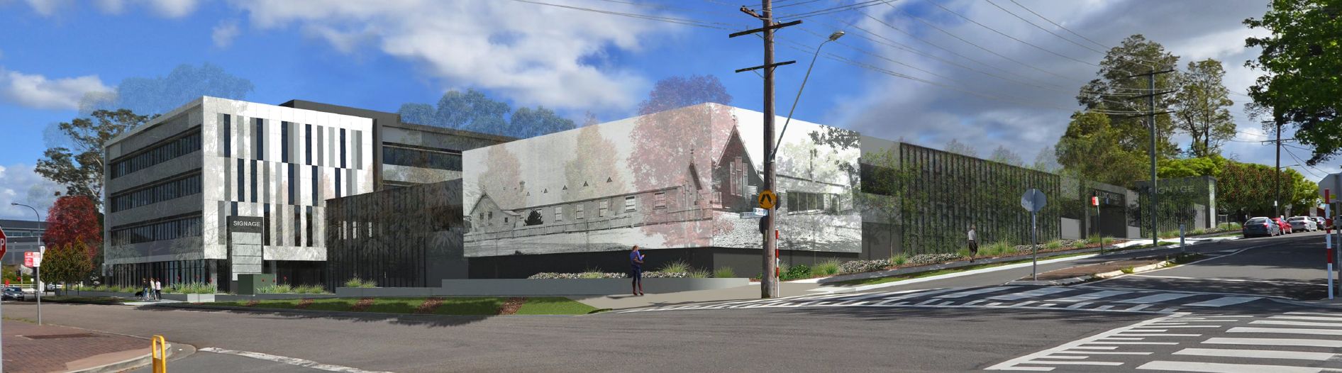

**Figure 8: View of the development from the public domain interface on Frederick and Smith Street**

A generous amount of landscaping along all street frontages enables appropriate screening and vertical scale to soften the developments streetscape presentation. Amended plans provide green walls being incorporated into the carpark elevations facing Smith and Frederick Streets.

It is considered that the development meets the overall intent of the objectives under section 6.4 Façade Articulation and Section 6.5 Building Exteriors under the DCP.

* 1. **Tree Removal**

The Panel questioned the need for removal of all trees on the site, particularly along the boundaries of Smith Street and Frederick Streets and considers this a key assessment issue to be carefully worked through.

Due to level changes across the site, location of existing and required services, and requirements of the Charlestown Streetscape Masterplan, all trees are proposed to be removed and replaced with appropriate trees for the site and road reserves.

Council acknowledges to allow for retention of any tree would require significant amendments to layout and design, compromising the function of the health services facility. Significant consideration was given to the Tree Protection Zone (TPZ) dimensions for individual trees as detailed in Tree Assessment table of the submitted Arborist Report and Tree Protection Zone detail submitted in the architectural plans as demonstrated by figure 9 below.

Of particular note the impacts associated with the removal of Tree 22 (*Eucalyptus bicostata*) were raised due to containing hollows which attributed an increased environmental value.

Tree 22 is noted to be located in the south-western corner of the site. This is a prominent corner location with a strategic objective to provide an activated street frontage. As such to retain the significant tree would result in a design outcome that is contradictory to the strategic intent for the locality.

The arborist report submitted notes Tree 22 appears to be in declining condition and position conflicts with the proposed design and is not suited for retention based on increasing personal and property risk due to its declining structural condition.

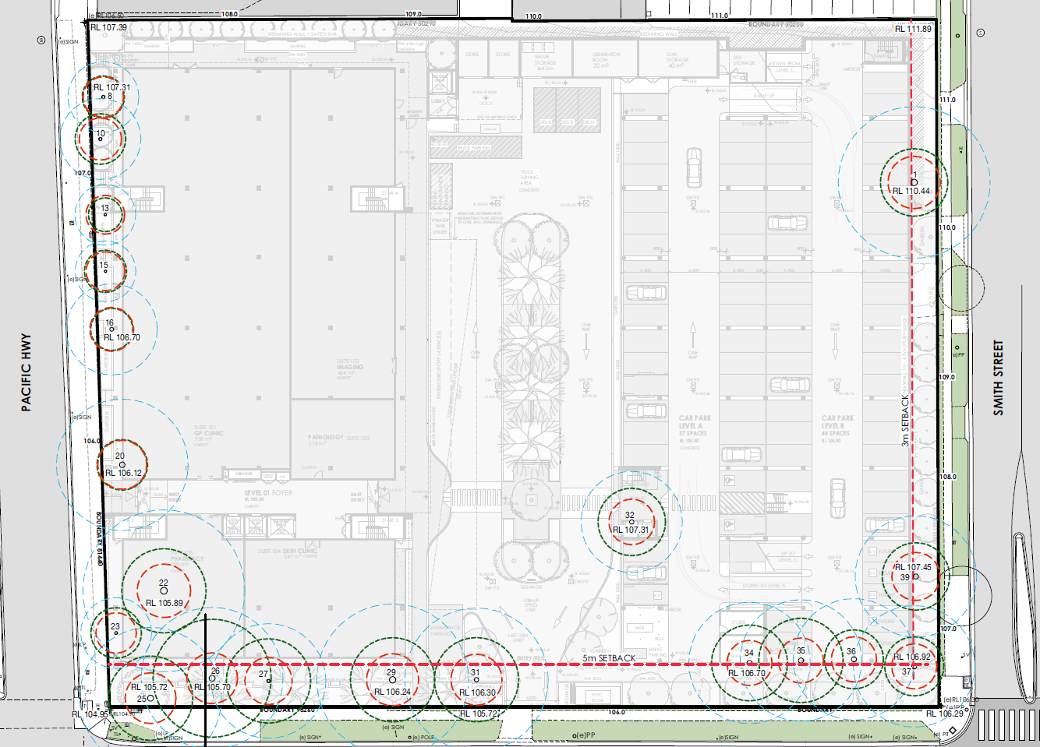

**Figure 9: Proposed Tree Removal/ Existing Tree Protection Zone**

Council’s Development Planner - Flora and fauna has reviewed the assessment and considers the removal appropriate subject to conditions for all salvageable hollows to be relocated off site.

Conditions for pre-clearance fauna surveys, removal of fauna habitat (supervised by a qualified ecologist) will form part of any conditions of consent to off-set the impacts of the tree removal occurring on the site.

The development includes a 5-metre-wide vegetative buffer along the southern site boundary parallel to Frederick Street. The development would result in significant disruption to both the canopy within the identified TPZ and the root protection zone, to achieve the built outcome and Council’s required streetscape upgrades. Replanting of the southern boundary with appropriate species in the 5-metre setback will achieve a suitable long-term outcome with no structurally compromised plantings.

The eastern boundary will be subject to major and unsustainable levels of encroachment caused by the proposed parking structures and driveway access. These trees are assessed with moderate to high retention value and their removal will be offset by inclusion of suitable replacement species within the landscaping of the site.

There are two trees within Council’s road reserve which have been assessed to have a moderate retention value. The trees will be subject to major and unsustainable levels of encroachment caused by the provision of utilities and access into the subject site. Council’s Natural Assets department has reviewed this element of the proposal and support their removal and replacement with tree species and upgrades in accordance with the Charlestown Streetscape Master Plan.

Locally occurring species aligning with the Charlestown Streetscape Masterplan are proposed to offset the tree removal and to meet the desired future character of the site and area.

Council raises no objections to this approach and support the tree removal subject to appropriate conditions for the replacement tree planting, habitat supplementation, and clearing protocols.

* 1. **Traffic & Vehicle Access**

The proposed development includes site access from Frederick Street and Charles Street.

Initial concerns were raised about the proposed development and Council’s intended future Charlestown to Whitebridge shared path which is identified along Fredrick Street. The section of Fredrick Street fronting the site is planned to be a footpath and level separated cycleway, however no final design has been complete or adopted for implementation.

The underlying issues raised related to vehicle access along Frederick Street and potential for pedestrian safety of the future shared path when the development is in operation.

The Frederick street access has been the subject of much discussion with Council. A meeting between the applicant and Council’s Traffic Engineer and planning officers was held on 12 April to discuss the matter in detail and provide direction to move forward.

Subject to information provided an amended suite of plans has been provided demonstrating an outcome that is generally consistent with the Charlestown Streetscape Masterplan. The final design presents minor variation to the width of the footpath fronting the buildings and the width of the adjoining landscaped strip (2m wide footpath and 3.05m wide landscaped strip). This allows for additional deep soil landscaping along this frontage

To reduce potential conflicts between pedestrian and vehicle movements the internal connection to the on-site carpark has been removed making the Frederick Street vehicle entrance only for patient drop off. In addition, signage is proposed to direct people who are not dropping off or picking up patients to the Smith Street carpark entry in accordance with the wayfinding signage plan.

This is considered to safely provide for pedestrian requirements of patients and passers-by.

Council acknowledges it is essential for the operation of the health services facility to provide level, safe and convenient drop off and pick up for mobility impaired patients. As such, it is supported that the Frederick street access be retained for this function, as well as servicing and emergency vehicles.

Council is satisfied the development access has been suitably resolved.

* 1. **Car Parking**

The application included the construction of a multi-level car park (three levels), providing 245 onsite car parking spaces.

Clarity was sought to confirm the extent of staff and future use to ensure that the development proposed would not be restricted for future users.

A Traffic & Parking Assessment report prepared by InTersect Traffic (Ref: 22/028 dated April 2023) provided an overview of the proposed uses and parking rate requirements under this section of the DCP.

The following rates will be used in the assessment of the proposed development:

**Retail Tenancies / Shops**

Car Parking – 1 space per 25 m2 GFA (Area less than 5,000 m2)

**Hospital – Beds**

1 space per 2 beds, plus 1 space per 2 staff, plus Ambulance spaces

**Medical Centres – GP Clinic, Imaging Tenancy, Skin Clinic**

Car Parking – 1 space per on-duty practitioner plus 1 space per 2 additional equivalent fulltime employees plus 1.5 spaces per consulting room plus 1 space for delivery and collection service.

**Medical Centres – Collection Centre (Pathology)**

Car Parking – 1 space plus 1 space per collection room plus 1 space for delivery and collection service.

**Medical Centres – Day Surgery**

Car Parking – 1 space per on-duty practitioner plus 1 space per 2 additional equivalent fulltime employees plus 1.5 spaces per consulting room plus 1 space for delivery and collection service and 1 space per 2 operating theatres.

The following is a breakdown of the proposed uses and calculated car parking spaces required (note consulting rooms have been calculated per each on-duty practitioner):

**Level 1 (Ground Floor)**

* use as a GP Clinic with capacity for 15 practitioners, three nurses and three administration staff (938m2)
  + Car parking = 15 + 6/2 + 15 x 1.5 + 1 = 42 spaces
* an Imaging tenancy with capacity for 5 practitioners and two administration staff (464m2)
  + Car parking = 5 + 2/2 + 5 x 1.5 + 1 = 15 spaces
* a pathology tenancy with 4 collection rooms (118m2)
  + Car parking = 1 + 4 x 1 + 1 = 6 spaces
* a retail pharmacy (220m2)
  + 1 space per 25m2 = Car parking for 220m2 = 9 spaces.
* a skin clinic with capacity for up to 5 practitioners, two nurses and two administration staff (247m2)
  + Car parking = 5 + 4/2 + 5 x 1.5 + 1 = 16 spaces

**Level 2 & 3** has been designed to accommodate the following, which will be subject to a separate DA for the fit out:

* 26 health consulting rooms both totalling 2,289m2 with the capacity for:
  + 25 medical and general consulting tenancies (Level 2)
  + 13 allied health tenancies (Level 3)
  + Proposed peak occupation of 39 on-site practitioners + 40 administration staff
    - Car parking = 39 + 40/2 + 39 x 1.5 = 118 spaces

**Level 4** has been designed to accommodate the following, which will be subject to a separate DA for the fit out:

* private hospital or day surgery with 23 beds and two operating theatres with up to 2 doctors, 2 anaesthetists and 15 nurses on-site at any one time (2,299m2)
  + Car parking = 4 + 16/2 + 2 x 1.5 + 1 = 16 spaces; and
  + Car parking = 23 hospital beds/2 = 12 spaces.
  + 2 dedicated ambulance spaces

**Total**

Car Parking required = **42 + 15 + 6 + 9 + 16 + 118 + 16 + 12 = 234 spaces.**

The development can meet the numerical requirements for parking, with an excess of 11 spaces which is supported to accommodate the daily operations of the proposed health services facility.

The parking infrastructure is required to be designed and constructed in accordance with Australian Standards.

* 1. **Charlestown Area Town Plan**

The Panel requested a clear understanding of Council’s requirements for public infrastructure upgrading. Detailed cross sections have been provided showing the relationship between the street and footpath as proposed.

The development site is located within the Charlestown strategic economic centre. Medical uses are identified to support a growing population and are consistent with the desired future character of Charlestown as articulated within the Lake Macquarie Local Strategic Planning Statement. The development site is identified within Part 10.1 Charlestown Town Centre – Area Plan, Block N, as indicated in the Figure below:

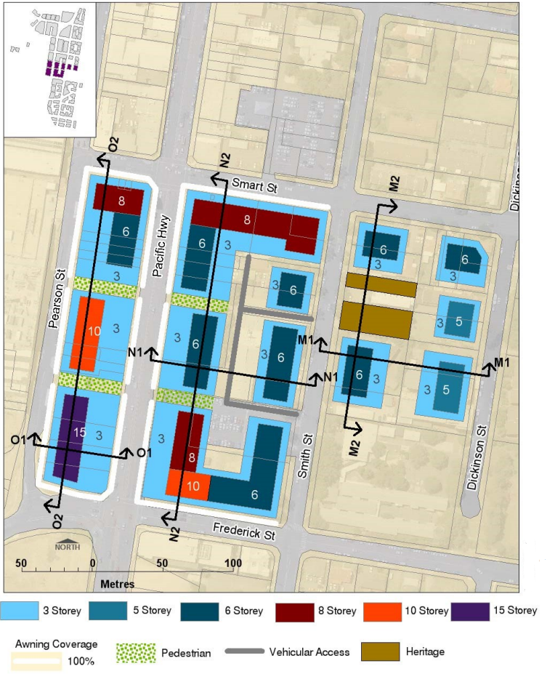

**Figure 10: Block Plan N**

The current DCP block plans provide a contextual built form to indicate the location of massing in relation to boundary setbacks and street edge.

The Block Plan indicates a built form in a ‘U’ shape configuration for development to front the whole of the Pacific Highway, Frederick Street and part of Smith Street with access off Smith Street and car parking within the centre.

Council has recently undertaken a review of the planning framework for Charlestown. A planning proposal has been prepared to amend LEP zones and development standards and a revised DCP Area Plan being prepared to amend the built form controls. These plans have been endorsed by Council for exhibition, although exhibition has not yet commenced.

The development has been reviewed by Council’s Senior Strategic Planner who is currently reviewing the planning framework for Charlestown and notes the development is consistent with the zone and maximum height of buildings proposed through the planning proposal. The proposed bulk and scale of the development is considered compatible with the existing prevailing character of the surrounding area and the future character standards proposed for the site under the draft Area Plan.

Of note the draft Area Plan no longer identifies the pedestrian walkway from Pacific Highway to Smith Street on this site, which is consistent with the proposed design.

The proposed development meets the desired setbacks as indicated within the section details shown below being partially built to the boundary on the Pacific Highway, 5m off Frederick Street, and 3m from Smith Street.

Block Plan N would indicate development fronting the Pacific Highway to be built to the street boundary for the first three storeys, in addition to each frontage along Frederick Street and part Smith Street.

The proposed development will see the building being built to the boundary on The Pacific Highway for four storeys and setback from Frederick Street with a multi-level car park (three storeys) fronting part of Frederick Street and the whole of Smith Street.

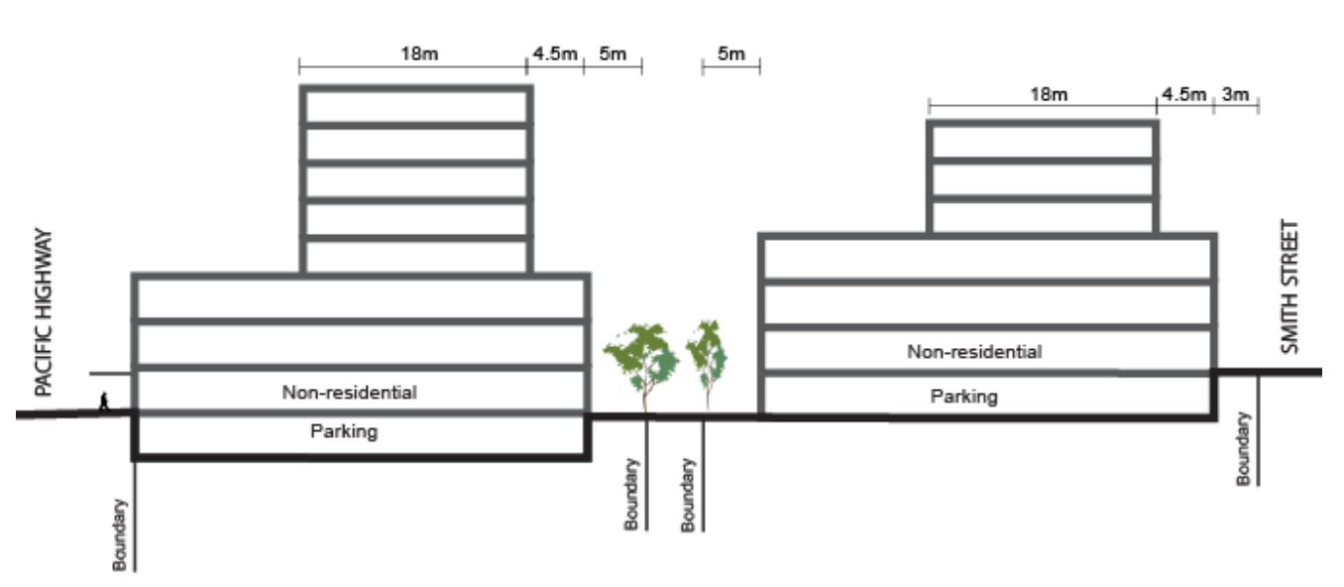

**Figure 11: Block N – Section Detailing Interface between Pacific Highway and Smith Street**

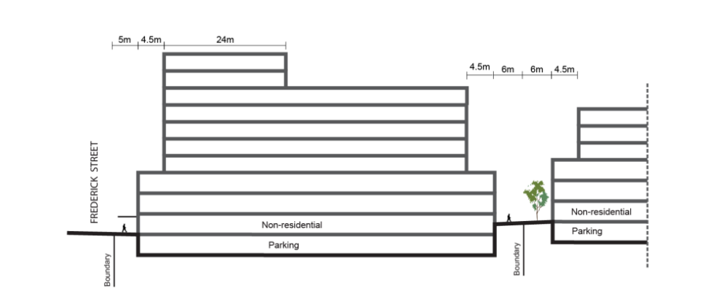

**Figure 12: Block N – Section Detailing Interface between Frederick Street**

Whilst the proposal is not in strict compliance with the vertical setbacks from the Pacific Highway and or overall Block Plan, the proposed building is considerably lower in height then what is permitted, and a reduced bulk and scale compared than the maximum allowable to the Block Plan.

Council’s Strategic Planner would note the massing and street wall proposed to the main building are consistent with the desired built form for the commercial zone, and raises no objections to the development form from a strategic perspective.

The development setback from Frederick Street has enabled greater landscaped area that will contribute to the amenity and connectivity of the public domain along this interface.

The separate car parking structure adjoining Smith Street is not consistent with the existing or draft DCP. However, decorative screens and landscaping are proposed to the car parking structure which suitably screen it from the street and provide an appropriate level of streetscape amenity. This will provide a softer streetscape interface in addition to reducing bulk and vertical scale of carpark. This is considered an appropriate design response to nearby development, which complements the streetscape.

It has been considered that the development provides a design that appropriately responds to the Area Plan. The development proposes scale, height and setbacks that will contribute to the desired future character of the town centre.

* 1. **Safety and Security**

The site is within an area where there is evidence of reported crimes such as malicious damage to property, motor vehicle theft, break and intimidation, stalking & harassment / assault (non-domestic violence). The design incorporates the principles of Crime Prevention Through Building Design (CPTED) to minimise opportunities for crime, as detailed below:

* Staff Parking and patient parking only signage to be provided at the entry to parking levels to deter persons who are not patients or staff of the centre. Although, the staff parking are on Level 3 will be controlled through boom gates.
* Vehicle access point to be secured after hours with boom gates, or equivalent.
* Trees are to be underpruned, with low level plantings and groundcovers along the southern and eastern boundary.
* CCTV to be provided in the locations shown in the CCTV + Security Lighting plan in the architectural plan set (car park and internal/ external parts of the building). CCTV to be designed and installed in compliance with Australian Standard 806.1: Closed Circuit Television (CCTV) Management and Operation.
* A back to base security system to be installed on the site.
* Motion-activated security lighting to be provided in the locations shown in the CCTV + Security Lighting plan in the architectural plan set. Lighting is to be in accordance with Australian Standard 1158 – Lighting for roads and public spaces and Australian Standard 4282 – Control of the obtrusive effects of outdoor lighting.
* All surfaces on the building to be maintained regularly, with graffiti removed and damage repaired immediately to reduce repeat offending and further anti-social behaviour.
* Electronic access control measures will be implemented to restrict, channel, and encourage people into, and out of, the multi storey carpark after dark. Staff of the private hospital will be provided with security access devices for secure access.
* Way-finding signage and formal access routes will reduce potential for criminal activity.
* A policy will be put into place by tenants offering to walk workers to their vehicle after dark.
* The single vehicular access point to the multi-storey carpark from Smith Street will be provided with access restriction (boom gates, one-way spikes or other access control device) after dark to help reduce the opportunity for unauthorised entry and to regulate vehicle movement. Staff of the private hospital will be provided with security access devices for secure access. An intercom connecting to the private hospital will be provided for all other requests for access.

Additionally, the CPTED report by Wilson Planning (November 2022) includes a number of recommendations to enhance outcomes including after hour security patrols, CCTVs, intercom systems with cameras at the entry points, directional signs, maintenance plan. These will be imposed through conditions with any consent.

The design and crime prevention strategy have been reviewed and supported by Council's Community Planner – Youth and Safer Communities, and are considered suitable subject to conditions of consent.

* 1. **Mine Subsidence**

A Report on Mine Subsidence Desktop Assessment and Geotechnical Assessment have been prepared by Douglas Partners for the site and proposal.

Based on the review of available information, results of the pillar stability analysis and risk assessment within the report, concluded there is some risk of mine subsidence affecting the subject site.

Douglas Partners have recommended that the proposed structures should be designed to accommodate the mine subsidence parameters presented in their assessment. There is no grouting proposed and SANSW will only require increased strength of structural supports already proposed under the building to cater for their requirements. There will be no changes required external to the building footprint.

Subsidence Advisory NSW has granted approval under Section 22 of the Coal Mine Subsidence Act 2017. Approval is subject to compliance with the GTA’s set out in the determination, supplied with the application (Ref: TBA22-02908, dated 31 August 2022).

In accordance with the approval, the proposed structures are to be designed to be “safe, serviceable and any damage from mine subsidence shall be limited to ‘very slight’ damage in accordance with AS2870 (Damage Classification), and readily repairable” if subjected to the subsidence parameters outlined in the accepted Report on Mine Subsidence Assessment by Douglas Partners (Project 210780.01-June 2022).

An ‘Engineer Impact Statement’ and final design for acceptance by SA NSW will be required prior to construction, which must identify the:

1. Mine Subsidence Parameters used for the design.
2. Main building elements and materials.
3. Risk of damage due to mine subsidence
4. Design measures proposed to control the risks.
5. Provide certification that the design will ensure the improvement remains “safe, serviceable and any damage from mine subsidence shall be limited to ‘very slight’ in accordance with AS2870 (Damage Classification), and readily repairable”.
6. Comment on the:

* likely building damage in the event of mine subsidence.
* sensitivity of the design to greater levels of mine subsidence.

Subsidence Advisory NSW would also require survey monitoring reference marks on and around the circumference of the building(s) so that structure movement can be monitored should mine subsidence occur.

* 1. **Acoustic Impacts**

The acoustic assessment by Reverb Acoustics (September 2022) was prepared in support of this development application.

The purpose of the assessment was to determine the noise impact, within habitable spaces of the development from passing road traffic and commercial activity, and to ensure that noise levels comply with the requirements of the Roads and Maritime Services (RMS), Department of Planning and Environment (DPE), NSW Environment Protection Authority (EPA) and Lake Macquarie City Council (LMCC).

Further assessment has also been carried out to determine the noise impact of mechanical plant and site activities (i.e. vehicle movements) associated with the proposed development on nearby land users.

Long-term background noise level measurements were conducted by Reverb Acoustics for a nearby development in Smith Street. Additional attended noise level measurements were conducted at the south, east and west boundaries of the site during peak day and night periods. The selected locations are representative of the acoustic environment in the receiver areas and considered acceptable locations for determination of the background noise in accordance with Fact Sheet B of the EPA’s Noise Policy for Industry (NPfI). A summary of the results is shown below from Table 1 of the Noise Assessment.

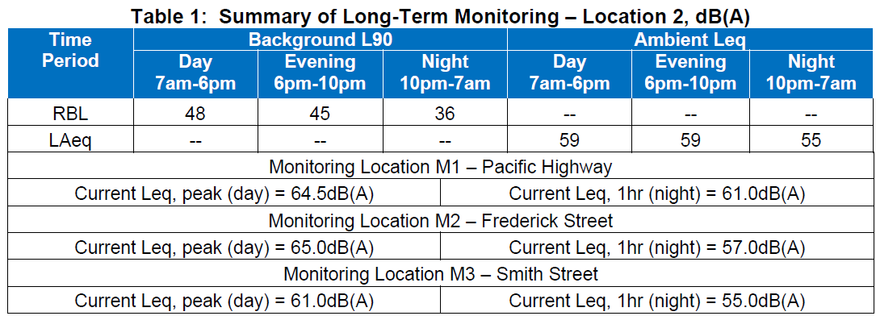

**Road Traffic Noise**

Road traffic noise was assessed in the submitted acoustic report, and was considered the development could achieve suitable comfort levels, subject to the conditions and recommendations.

**Site Noise / Mechanical Plant**

Suitable noise control measures were identified in the acoustic report for implementation to achieve satisfactory noise levels to the nearby residential area.

**Recommendations**

The report details recommendations for the following components of the proposed development to ensure impacts are managed:

* Glazing
* Roof / Ceiling Construction
* Wall Construction
* Mechanical Plant, and Carpark

The Noise Impact Assessment report has shown that the site is suitable for the intended purpose, providing the recommendations in Section 7.0 of the report are implemented. The assessment of external noise impacting on the development has resulted in the compilation of a schedule of minimum glazing, wall, roof construction, etc, to meet the requirements of the EPA, DPE and RMS. Providing the recommendations given in the report prepared by Reverb Acoustics (September 2022) are implemented, external noise impacts (i.e. road traffic, commercial activities, etc), will comply with the requirements of the EPA, RMS, DPE and LMCC within habitable spaces of the proposed development.

Council’s Environmental Health Officer has reviewed the findings and recommendations of this report and supports the development on the basis that the recommendations from Reverb Acoustics (September 2022) form part of any consent under this application.

**CONCLUSION**

This development application has been considered in accordance with the requirements of the EP&A Act and the Regulations as outlined in this report.

The proposal aligns with the strategic intent of the Charlestown Town Centre Area Plan and Charlestown Streetscape Master Plan. It is concluded that the development will provide additional medical services and jobs in one of the Hunter regions major commercial centres. The site is capable of accommodating the development with an acceptable level of impact.

The proposal has a high-quality design and is supported by design measures to improve the existing streetscape. The sitting is appropriate and the proposed landscaping will improve the public domain, amenity and the presentation of the building and the site the surrounding public areas.

The carparking meets the requirements of Council’s DCP and pedestrian linkages, access and circulation is adequately addressed.

Following a thorough assessment of the relevant planning controls, issues raised in submissions and the key issues identified in this report, it is considered that the application can be supported.

It is considered that the key issues as outlined in Section 5 have been resolved satisfactorily through amendments to the proposal and/or in the recommended draft conditions at **Attachment A**.

1. **RECOMMENDATION**

That the Development Application DA/2630/2022 for health services facilities at 31-33 Smith Street Charlestown be APPROVED pursuant to Section 4.16(1)(a) of the *Environmental Planning and Assessment Act 1979* be approved subject to the draft conditions of consent attached to this report at Attachment A.

The following attachments are provided:

* Attachment A: Draft Conditions of consent
* Attachment B: Supplementary plans and documents schedule